Signed Number Operations, Comparison and Ordering

Operations

Addition
# Source: AI Source: Provided by: [Data Path: Persons Table -> ID Column: 1, Name_En Column: Motasem Essam] -> From: [ChatGPT] on [7/11/2026]
Addition of signed numbers is the arithmetic operation of combining two or more numbers that may be positive (+), negative (−), or zero (0) to obtain their sum.
Unlike whole number addition, signed number addition considers both the magnitude (absolute value) and the sign of each number.

Definition
# Source: AI Source: Provided by: [Data Path: Persons Table -> ID Column: 1, Name_En Column: Motasem Essam] -> From: [ChatGPT] on [7/11/2026]
Signed number addition is the process of finding the sum of two or more signed numbers while considering both their values and their signs.
Mathematically:
$$a+b=c$$
where:
- $a$is the first addend.
- $b$is the second addend.
- $c$is the sum.
Signed number addition is commonly performed on the set of integers ($Z$).

Addition Symbol
# Source: AI Source: Provided by: [Data Path: Persons Table -> ID Column: 1, Name_En Column: Motasem Essam] -> From: [ChatGPT] on [7/11/2026]
The symbol for addition is:
$$+$$
Example:
$$5+(-3)=2$$

Rules for Adding Signed Numbers

1. Positive + Positive
# Source: AI Source: Provided by: [Data Path: Persons Table -> ID Column: 1, Name_En Column: Motasem Essam] -> From: [ChatGPT] on [7/11/2026]
Add the absolute values and keep the positive sign.
$$\left(+a)+(+b)=+(a+b\right)$$
Example:
$$(+7)+(+5)=+12$$

2. Negative + Negative
# Source: AI Source: Provided by: [Data Path: Persons Table -> ID Column: 1, Name_En Column: Motasem Essam] -> From: [ChatGPT] on [7/11/2026]
Add the absolute values and keep the negative sign.
$$\left(-a)+(-b)=-(a+b\right)$$
Example:
$$(-8)+(-6)=-14$$

3. Positive + Negative
# Source: AI Source: Provided by: [Data Path: Persons Table -> ID Column: 1, Name_En Column: Motasem Essam] -> From: [ChatGPT] on [7/11/2026]
Subtract the smaller absolute value from the larger absolute value.
Keep the sign of the number with the larger absolute value.
Example:
$$(+12)+(-5)=+7$$

Example:
$$(+9)+(-15)=-6$$

4. Negative + Positive
# Source: AI Source: Provided by: [Data Path: Persons Table -> ID Column: 1, Name_En Column: Motasem Essam] -> From: [ChatGPT] on [7/11/2026]
Apply the same rule.
Example:
$$(-18)+(+7)=-11$$

Example:
$$(-4)+(+10)=+6$$

Addition Using a Number Line
# Source: AI Source: Provided by: [Data Path: Persons Table -> ID Column: 1, Name_En Column: Motasem Essam] -> From: [ChatGPT] on [7/11/2026]
Example:
$$-3+5$$
Steps:
- Start at −3.
- Move 5 units to the right.
- Stop at 2.
Therefore,
$$-3+5=2$$

Example:
$$6+(-8)$$
Steps:
- Start at 6.
- Move 8 units to the left.
- Stop at −2.
Therefore,
$$6+(-8)=-2$$

Examples
# Source: AI Source: Provided by: [Data Path: Persons Table -> ID Column: 1, Name_En Column: Motasem Essam] -> From: [ChatGPT] on [7/11/2026]
Example 1
$$(+15)+(+8)=23$$

Example 2
$$(-11)+(-9)=-20$$

Example 3
$$(+20)+(-7)=13$$

Example 4
$$(-14)+(+5)=-9$$

Example 5
$$(-25)+(+40)=15$$

Example 6
$$(+30)+(-45)=-15$$

Vertical Addition
# Source: AI Source: Provided by: [Data Path: Persons Table -> ID Column: 1, Name_En Column: Motasem Essam] -> From: [ChatGPT] on [7/11/2026]
Example:
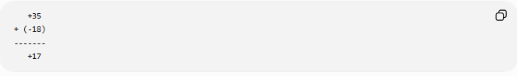
+35
+ (-18)
-------
+17
Calculation:
$$35+(-18)=17$$

Properties of Signed Number Addition
# Source: AI Source: Provided by: [Data Path: Persons Table -> ID Column: 1, Name_En Column: Motasem Essam] -> From: [ChatGPT] on [7/11/2026]
Let $a$, $b$, and $c$be integers.

1. Closure Property
# Source: AI Source: Provided by: [Data Path: Persons Table -> ID Column: 1, Name_En Column: Motasem Essam] -> From: [ChatGPT] on [7/11/2026]
The sum of two signed numbers is always a signed number.
$$a,b∈Z⇒a+b∈Z$$
Example:
$$-8+13=5$$

2. Commutative Property
# Source: AI Source: Provided by: [Data Path: Persons Table -> ID Column: 1, Name_En Column: Motasem Essam] -> From: [ChatGPT] on [7/11/2026]
Changing the order does not change the sum.
$$a+b=b+a$$
Example:
$$(-4)+9=9+(-4)=5$$

3. Associative Property
# Source: AI Source: Provided by: [Data Path: Persons Table -> ID Column: 1, Name_En Column: Motasem Essam] -> From: [ChatGPT] on [7/11/2026]
Changing the grouping does not change the sum.
$$\left(a+b)+c=a+(b+c\right)$$
Example:
$$(-2+6)+5=-2+(6+5)=9$$

4. Identity Property
# Source: AI Source: Provided by: [Data Path: Persons Table -> ID Column: 1, Name_En Column: Motasem Essam] -> From: [ChatGPT] on [7/11/2026]
Zero is the additive identity.
$$a+0=a$$
Example:
$$-27+0=-27$$

5. Additive Inverse Property
# Source: AI Source: Provided by: [Data Path: Persons Table -> ID Column: 1, Name_En Column: Motasem Essam] -> From: [ChatGPT] on [7/11/2026]
Every signed number has an opposite (additive inverse).
$$a+(-a)=0$$
Example:
$$18+(-18)=0$$

Checking Addition
# Source: AI Source: Provided by: [Data Path: Persons Table -> ID Column: 1, Name_En Column: Motasem Essam] -> From: [ChatGPT] on [7/11/2026]
Addition can be verified using subtraction.
Example:
$$-12+19=7$$
Check:
$$7-19=-12$$
Since the original addend is obtained, the addition is correct.

Real-Life Applications
# Source: AI Source: Provided by: [Data Path: Persons Table -> ID Column: 1, Name_En Column: Motasem Essam] -> From: [ChatGPT] on [7/11/2026]
Addition of signed numbers is used in:
- Financial transactions (profits and debts)
- Temperature changes
- Elevation above and below sea level
- Sports scoring
- Accounting
- Scientific measurements
- Computer programming
- Navigation

Real-Life Examples
# Source: AI Source: Provided by: [Data Path: Persons Table -> ID Column: 1, Name_En Column: Motasem Essam] -> From: [ChatGPT] on [7/11/2026]
1. Bank Account
A bank account has a balance of −50 dollars (overdraft).
A deposit of 80 dollars is made.
$$-50+80=30$$
The new balance is 30 dollars.

2. Temperature Change
The temperature is −6°C.
It rises by 9°C.
$$-6+9=3$$
The new temperature is 3°C.

3. Elevator Movement
An elevator starts at −2 (second basement).
It moves up 5 floors.
$$-2+5=3$$
The elevator stops at the 3rd floor.

4. Football Score
A team receives a −3 point penalty and later scores 10 points.
$$-3+10=7$$
The team's total score is 7 points.

5. Mountain Climbing
A climber is at −100 meters relative to sea level.
The climber ascends 250 meters.
$$-100+250=150$$
The climber is now 150 meters above sea level.

6. Business Profit
A company loses 120 dollars in the morning but earns 200 dollars in the afternoon.
$$-120+200=80$$
The company has a net profit of 80 dollars.

7. Stock Market
A stock decreases by 15 points and later increases by 22 points.
$$-15+22=7$$
The stock ends 7 points above its starting value.

8. Game Score
A player loses 5 points and later gains 12 points.
$$-5+12=7$$
The player's final score increases by 7 points.

Common Mistakes
# Source: AI Source: Provided by: [Data Path: Persons Table -> ID Column: 1, Name_En Column: Motasem Essam] -> From: [ChatGPT] on [7/11/2026]
- Adding the signs instead of the numbers.
- Forgetting to compare absolute values when the signs are different.
- Keeping the wrong sign after subtraction.
- Confusing subtraction with adding a negative number.
- Ignoring the additive inverse property.

Key Points
# Source: AI Source: Provided by: [Data Path: Persons Table -> ID Column: 1, Name_En Column: Motasem Essam] -> From: [ChatGPT] on [7/11/2026]
- Signed number addition considers both the value and the sign.
- Numbers with the same sign are added, and the common sign is kept.
- Numbers with different signs are subtracted, and the sign of the larger absolute value is kept.
- Zero is the additive identity.
- Every signed number has an additive inverse.
- Signed number addition satisfies the closure, commutative, and associative properties.

Whole Number Addition vs. Signed Number Addition
# Source: AI Source: Provided by: [Data Path: Persons Table -> ID Column: 1, Name_En Column: Motasem Essam] -> From: [ChatGPT] on [7/11/2026]
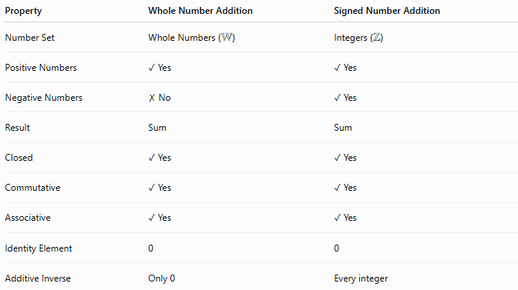
Property | Whole Number Addition | Signed Number Addition
Number Set | Whole Numbers ($W$) | Integers ($Z$)
Positive Numbers | ✓ Yes | ✓ Yes
Negative Numbers | ✗ No | ✓ Yes
Result | Sum | Sum
Closed | ✓ Yes | ✓ Yes
Commutative | ✓ Yes | ✓ Yes
Associative | ✓ Yes | ✓ Yes
Identity Element | 0 | 0
Additive Inverse | Only 0 | Every integer

Conclusion
# Source: AI Source: Provided by: [Data Path: Persons Table -> ID Column: 1, Name_En Column: Motasem Essam] -> From: [ChatGPT] on [7/11/2026]
Addition of signed numbers extends ordinary addition by including positive and negative numbers. The operation follows simple rules based on the signs of the numbers: numbers with the same sign are added, while numbers with different signs are subtracted, keeping the sign of the number with the greater absolute value. Signed number addition is fundamental in algebra and is widely used in finance, science, engineering, computer programming, and many everyday situations involving gains, losses, increases, and decreases.

Subtraction
# Source: AI Source: Provided by: [Data Path: Persons Table -> ID Column: 1, Name_En Column: Motasem Essam] -> From: [ChatGPT] on [7/11/2026]
Subtraction of signed numbers is the arithmetic operation of finding the difference between two signed numbers. It can be performed by adding the opposite (additive inverse) of the number being subtracted.
Unlike whole number subtraction, signed number subtraction may produce positive, negative, or zero results.

Definition
# Source: AI Source: Provided by: [Data Path: Persons Table -> ID Column: 1, Name_En Column: Motasem Essam] -> From: [ChatGPT] on [7/11/2026]
Signed number subtraction is the process of finding the difference between two signed numbers by subtracting one number from another.
Mathematically:
$$a-b=c$$
where:
- $a$is the minuend (the number from which another number is subtracted).
- $b$is the subtrahend (the number being subtracted).
- $c$is the difference.
Signed number subtraction is commonly performed on the set of integers ($Z$).

Subtraction Symbol
# Source: AI Source: Provided by: [Data Path: Persons Table -> ID Column: 1, Name_En Column: Motasem Essam] -> From: [ChatGPT] on [7/11/2026]
The symbol for subtraction is:
$$-$$
Example:
$$8-3=5$$

Subtraction as Addition of the Opposite
# Source: AI Source: Provided by: [Data Path: Persons Table -> ID Column: 1, Name_En Column: Motasem Essam] -> From: [ChatGPT] on [7/11/2026]
The most important rule for subtracting signed numbers is:
$$a-b=a+(-b)$$
In other words:
Subtracting a number is the same as adding its opposite (additive inverse).
Examples:
$$8-(-3)=8+3=11 \\ 5-(+7)=5+(-7)=-2$$

Rules for Subtracting Signed Numbers

1. Positive − Positive
# Source: AI Source: Provided by: [Data Path: Persons Table -> ID Column: 1, Name_En Column: Motasem Essam] -> From: [ChatGPT] on [7/11/2026]
Subtract the absolute values.
Keep the sign of the number with the larger absolute value.
Example:
$$12-5=7$$

Example:
$$5-12=-7$$

2. Positive – Negative
# Source: AI Source: Provided by: [Data Path: Persons Table -> ID Column: 1, Name_En Column: Motasem Essam] -> From: [ChatGPT] on [7/11/2026]
Change subtraction to addition.
$$(+a)-(-b)=a+b$$
Example:
$$8-(-6)=8+6=14$$

3. Negative − Positive
# Source: AI Source: Provided by: [Data Path: Persons Table -> ID Column: 1, Name_En Column: Motasem Essam] -> From: [ChatGPT] on [7/11/2026]
Change subtraction to addition of the opposite.
Example:
$$-9-(+4)=-9+(-4)=-13$$

4. Negative − Negative
# Source: AI Source: Provided by: [Data Path: Persons Table -> ID Column: 1, Name_En Column: Motasem Essam] -> From: [ChatGPT] on [7/11/2026]
Subtracting a negative becomes addition.
Example:
$$-15-(-7)=-15+7=-8$$

Subtraction Using a Number Line
# Source: AI Source: Provided by: [Data Path: Persons Table -> ID Column: 1, Name_En Column: Motasem Essam] -> From: [ChatGPT] on [7/11/2026]
Example 1
$$4-7$$
Steps:
- Start at 4.
- Move 7 units left.
- Stop at −3.
Therefore,
$$4-7=-3$$

Example 2
$$-5-(-8)$$
Steps:
- Start at −5.
- Subtracting −8 means moving 8 units right.
- Stop at 3.
Therefore,
$$-5-(-8)=3$$

Examples
Example 1
$$18-(+6)=12$$

Example 2
$$7-(-9)=16$$

Example 3
$$-10-(+5)=-15$$

Example 4
$$-12-(-4)=-8$$

Example 5
$$25-40=-15$$

Example 6
$$-18-(-25)=7$$

Vertical Subtraction
# Source: AI Source: Provided by: [Data Path: Persons Table -> ID Column: 1, Name_En Column: Motasem Essam] -> From: [ChatGPT] on [7/11/2026]
Example:
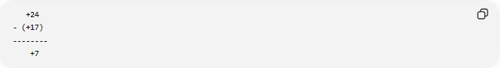
+24
- (+17)
--------
+7
Calculation:
$$24-17=7$$

Example:
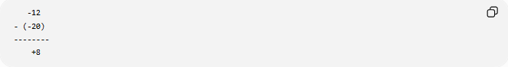
-12
- (-20)
--------
+8
Calculation:
$$-12-(-20)=-12+20=8$$

Properties of Signed Number Subtraction
# Source: AI Source: Provided by: [Data Path: Persons Table -> ID Column: 1, Name_En Column: Motasem Essam] -> From: [ChatGPT] on [7/11/2026]
Let $a$, $b$, and $c$be integers.

1. Closure Property
# Source: AI Source: Provided by: [Data Path: Persons Table -> ID Column: 1, Name_En Column: Motasem Essam] -> From: [ChatGPT] on [7/11/2026]
The difference of two signed numbers is always a signed number.
$$a,b∈Z⇒a-b∈Z$$
Example:
$$-5-8=-13$$

2. Not Commutative
# Source: AI Source: Provided by: [Data Path: Persons Table -> ID Column: 1, Name_En Column: Motasem Essam] -> From: [ChatGPT] on [7/11/2026]
Changing the order changes the result.
$$a-b≠b-a$$
Example:
$$10-3=7$$
but
$$3-10=-7$$
Therefore,
$$10-3≠3-10$$

3. Not Associative
# Source: AI Source: Provided by: [Data Path: Persons Table -> ID Column: 1, Name_En Column: Motasem Essam] -> From: [ChatGPT] on [7/11/2026]
Changing the grouping changes the result.
$$\left(a-b)-c≠a-(b-c\right)$$
Example:
$$(12-5)-2=5$$
but
$$12-(5-2)=9$$
Therefore, subtraction is not associative.

4. Identity Property
# Source: AI Source: Provided by: [Data Path: Persons Table -> ID Column: 1, Name_En Column: Motasem Essam] -> From: [ChatGPT] on [7/11/2026]
Subtracting zero leaves the number unchanged.
$$a-0=a$$
Example:
$$-35-0=-35$$

5. Subtracting a Number from Itself
# Source: AI Source: Provided by: [Data Path: Persons Table -> ID Column: 1, Name_En Column: Motasem Essam] -> From: [ChatGPT] on [7/11/2026]
Every integer minus itself equals zero.
$$a-a=0$$
Example:
$$17-17=0$$

Checking Subtraction
# Source: AI Source: Provided by: [Data Path: Persons Table -> ID Column: 1, Name_En Column: Motasem Essam] -> From: [ChatGPT] on [7/11/2026]
Subtraction can be verified using addition.
Example:
$$15-(-8)=23$$
Check:
$$23+(-8)=15$$
Since the original minuend is obtained, the subtraction is correct.

Real-Life Applications
# Source: AI Source: Provided by: [Data Path: Persons Table -> ID Column: 1, Name_En Column: Motasem Essam] -> From: [ChatGPT] on [7/11/2026]
Subtraction of signed numbers is used in:
- Bank account balances
- Temperature changes
- Elevation calculations
- Profit and loss analysis
- Accounting
- Navigation
- Scientific measurements
- Computer programming

Real-Life Examples
# Source: AI Source: Provided by: [Data Path: Persons Table -> ID Column: 1, Name_En Column: Motasem Essam] -> From: [ChatGPT] on [7/11/2026]
1. Bank Account
A bank account has 40 dollars.
A withdrawal of 60 dollars is made.
$$40-60=-20$$
The account balance becomes −20 dollars (overdrawn).

2. Temperature Drop
The temperature is 5°C.
It decreases by 12°C.
$$5-12=-7$$
The new temperature is −7°C.

3. Elevator Movement
An elevator is on the 4th floor.
It moves down 7 floors.
$$4-7=-3$$
The elevator arrives at the 3rd basement level.

4. Mountain Elevation
A diver is −30 meters below sea level.
The diver descends another 15 meters.
$$-30-15=-45$$
The diver is now 45 meters below sea level.

5. Business Loss
A company has a profit of 150 dollars.
An expense of 220 dollars occurs.
$$150-220=-70$$
The company has a 70-dollar loss.

6. Game Score
A player has 25 points.
A penalty removes 30 points.
$$25-30=-5$$
The player's score becomes −5 points.

7. Stock Market
A stock is already down 8 points.
It drops another 5 points.
$$-8-5=-13$$
The stock is now 13 points below its starting value.

8. Debt Reduction
A person owes −120 dollars.
They reduce the debt by subtracting −50 dollars (removing part of the debt).
$$-120-(-50)=-70$$
The remaining debt is 70 dollars.

Common Mistakes
# Source: AI Source: Provided by: [Data Path: Persons Table -> ID Column: 1, Name_En Column: Motasem Essam] -> From: [ChatGPT] on [7/11/2026]
- Forgetting that subtracting a negative becomes addition.
- Confusing subtraction with addition when signs are involved.
- Keeping the wrong sign after converting subtraction to addition.
- Assuming subtraction is commutative.
- Forgetting to use the additive inverse.

Key Points
# Source: AI Source: Provided by: [Data Path: Persons Table -> ID Column: 1, Name_En Column: Motasem Essam] -> From: [ChatGPT] on [7/11/2026]
- Signed number subtraction is equivalent to adding the opposite.
- Use the rule:
$$a-b=a+(-b)$$
- Subtracting a negative becomes addition.
- Subtracting a positive becomes adding its negative.
- Signed number subtraction is closed on integers.
- It is not commutative.
- It is not associative.
- Subtracting zero leaves a number unchanged.
- A number subtracted from itself equals zero.

Signed Number Addition vs. Signed Number Subtraction
# Source: AI Source: Provided by: [Data Path: Persons Table -> ID Column: 1, Name_En Column: Motasem Essam] -> From: [ChatGPT] on [7/11/2026]
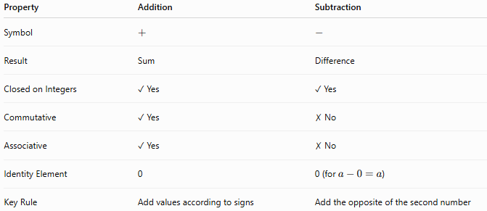
Property | Addition | Subtraction
Symbol | $$+$$ | $$-$$
Result | Sum | Difference
Closed on Integers | ✓ Yes | ✓ Yes
Commutative | ✓ Yes | ✗ No
Associative | ✓ Yes | ✗ No
Identity Element | 0 | 0 (for $a-0=a$)
Key Rule | Add values according to signs | Add the opposite of the second number

Conclusion
# Source: AI Source: Provided by: [Data Path: Persons Table -> ID Column: 1, Name_En Column: Motasem Essam] -> From: [ChatGPT] on [7/11/2026]
Subtraction of signed numbers is the arithmetic operation used to find the difference between two integers. It is performed by adding the additive inverse of the second number, making it closely related to signed number addition. Signed number subtraction is closed on the set of integers but is not commutative or associative. Mastering the rule "subtracting a number is the same as adding its opposite" is essential for solving algebraic expressions and real-world problems involving gains, losses, temperature changes, elevation, and financial transactions.

Multiplication
# Source: AI Source: Provided by: [Data Path: Persons Table -> ID Column: 1, Name_En Column: Motasem Essam] -> From: [ChatGPT] on [7/11/2026]
Multiplication of signed numbers is the arithmetic operation of finding the product of two or more numbers that may be positive (+), negative (−), or zero (0).
Unlike whole number multiplication, signed number multiplication requires applying sign rules in addition to multiplying the absolute values of the numbers.

Definition
# Source: AI Source: Provided by: [Data Path: Persons Table -> ID Column: 1, Name_En Column: Motasem Essam] -> From: [ChatGPT] on [7/11/2026]
Signed number multiplication is the process of multiplying two or more signed numbers by multiplying their absolute values and determining the sign of the result according to the rules of signs.
Mathematically:
$$a×b=c$$
where:
- $a$is the multiplicand.
- $b$is the multiplier.
- $c$is the product.
Signed number multiplication is commonly performed on the set of integers ($Z$).

Multiplication Symbols
# Source: AI Source: Provided by: [Data Path: Persons Table -> ID Column: 1, Name_En Column: Motasem Essam] -> From: [ChatGPT] on [7/11/2026]
Common symbols for multiplication include:
$$×,⋅,(*)$$
Example:
$$6×(-4)=-24$$

Rules for Multiplying Signed Numbers

1. Positive × Positive
# Source: AI Source: Provided by: [Data Path: Persons Table -> ID Column: 1, Name_En Column: Motasem Essam] -> From: [ChatGPT] on [7/11/2026]
Multiply the absolute values.
The result is positive.
$$\left(+a)×(+b)=+(ab\right)$$
Example:
$$(+7)×(+5)=+35$$

2. Negative × Negative
# Source: AI Source: Provided by: [Data Path: Persons Table -> ID Column: 1, Name_En Column: Motasem Essam] -> From: [ChatGPT] on [7/11/2026]
Multiply the absolute values.
The result is positive.
$$\left(-a)×(-b)=+(ab\right)$$
Example:
$$(-8)×(-6)=+48$$

3. Positive × Negative
# Source: AI Source: Provided by: [Data Path: Persons Table -> ID Column: 1, Name_En Column: Motasem Essam] -> From: [ChatGPT] on [7/11/2026]
Multiply the absolute values.
The result is negative.
$$\left(+a)×(-b)=-(ab\right)$$
Example:
$$(+9)×(-4)=-36$$

4. Negative × Positive
# Source: AI Source: Provided by: [Data Path: Persons Table -> ID Column: 1, Name_En Column: Motasem Essam] -> From: [ChatGPT] on [7/11/2026]
Multiply the absolute values.
The result is negative.
$$\left(-a)×(+b)=-(ab\right)$$
Example:
$$(-11)×(+3)=-33$$

Sign Rule Summary
# Source: AI Source: Provided by: [Data Path: Persons Table -> ID Column: 1, Name_En Column: Motasem Essam] -> From: [ChatGPT] on [7/11/2026]
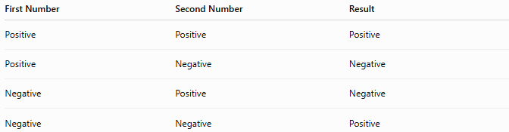
First Number | Second Number | Result
Positive | Positive | Positive
Positive | Negative | Negative
Negative | Positive | Negative
Negative | Negative | Positive
A simple memory aid:
- Same signs → Positive
- Different signs → Negative

Multiplication by Zero
# Source: AI Source: Provided by: [Data Path: Persons Table -> ID Column: 1, Name_En Column: Motasem Essam] -> From: [ChatGPT] on [7/11/2026]
Any signed number multiplied by zero equals zero.
$$a×0=0$$
Examples:
$$(-25)×0=0 \\ 0×18=0$$

Examples
# Source: AI Source: Provided by: [Data Path: Persons Table -> ID Column: 1, Name_En Column: Motasem Essam] -> From: [ChatGPT] on [7/11/2026]
Example 1
$$(+12)×(+4)=48$$

Example 2
$$(-7)×(+8)=-56$$

Example 3
$$(+15)×(-6)=-90$$

Example 4
$$(-9)×(-5)=45$$

Example 5
$$(-14)×0=0$$

Example 6
$$(-3)×(-4)×(+2)=24$$
Solution:
$$(-3)×(-4)=12 \\ 12×2=24$$

Vertical Multiplication
# Source: AI Source: Provided by: [Data Path: Persons Table -> ID Column: 1, Name_En Column: Motasem Essam] -> From: [ChatGPT] on [7/11/2026]
Example:
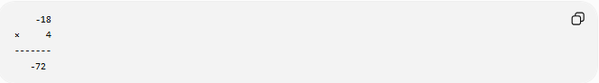
-18
× 4
-------
-72
Calculation:
$$(-18)×4=-72$$

Example:
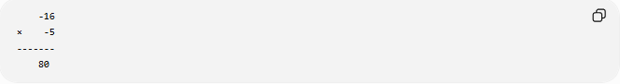
-16
× -5
-------
80
Calculation:
$$(-16)×(-5)=80$$

Properties of Signed Number Multiplication
# Source: AI Source: Provided by: [Data Path: Persons Table -> ID Column: 1, Name_En Column: Motasem Essam] -> From: [ChatGPT] on [7/11/2026]
Let $a$, $b$, and $c$be integers.

1. Closure Property
# Source: AI Source: Provided by: [Data Path: Persons Table -> ID Column: 1, Name_En Column: Motasem Essam] -> From: [ChatGPT] on [7/11/2026]
The product of two signed numbers is always a signed number.
$$a,b∈Z⇒a×b∈Z$$
Example:
$$(-8)×7=-56$$

2. Commutative Property
# Source: AI Source: Provided by: [Data Path: Persons Table -> ID Column: 1, Name_En Column: Motasem Essam] -> From: [ChatGPT] on [7/11/2026]
Changing the order does not change the product.
$$a×b=b×a$$
Example:
$$(-4)×6=6×(-4)=-24$$

3. Associative Property
# Source: AI Source: Provided by: [Data Path: Persons Table -> ID Column: 1, Name_En Column: Motasem Essam] -> From: [ChatGPT] on [7/11/2026]
Changing the grouping does not change the product.
$$\left(a×b)×c=a×(b×c\right)$$
Example:
$$((-2)×3)×5=(-2)×(3×5)=-30$$

4. Identity Property
# Source: AI Source: Provided by: [Data Path: Persons Table -> ID Column: 1, Name_En Column: Motasem Essam] -> From: [ChatGPT] on [7/11/2026]
The multiplicative identity is 1.
$$a×1=a$$
Example:
$$(-19)×1=-19$$

5. Zero Property
# Source: AI Source: Provided by: [Data Path: Persons Table -> ID Column: 1, Name_En Column: Motasem Essam] -> From: [ChatGPT] on [7/11/2026]
Multiplying any signed number by zero gives zero.
$$a×0=0$$
Example:
$$125×0=0$$

6. Distributive Property
# Source: AI Source: Provided by: [Data Path: Persons Table -> ID Column: 1, Name_En Column: Motasem Essam] -> From: [ChatGPT] on [7/11/2026]
Multiplication distributes over addition.
$$a(b+c)=ab+ac$$
Example:
$$(-4)(6+2)=(-4)(8)=-32$$
Also,
$$(-4)(6)+(-4)(2)=-24+(-8)=-32$$

Checking Multiplication
# Source: AI Source: Provided by: [Data Path: Persons Table -> ID Column: 1, Name_En Column: Motasem Essam] -> From: [ChatGPT] on [7/11/2026]
Multiplication can be verified using division.
Example:
$$(-8)×7=-56$$
Check:
$$-56÷7=-8$$
Since the original factor is obtained, the multiplication is correct.

Real-Life Applications
# Source: AI Source: Provided by: [Data Path: Persons Table -> ID Column: 1, Name_En Column: Motasem Essam] -> From: [ChatGPT] on [7/11/2026]
Multiplication of signed numbers is used in:
- Financial gains and losses
- Temperature changes over time
- Physics (direction and force)
- Elevation calculations
- Computer programming
- Coordinate geometry
- Accounting
- Engineering

Real-Life Examples
# Source: AI Source: Provided by: [Data Path: Persons Table -> ID Column: 1, Name_En Column: Motasem Essam] -> From: [ChatGPT] on [7/11/2026]
1. Financial Loss
A company loses 40 dollars each day for 6 days.
$$(-40)×6=-240$$
The total loss is 240 dollars.

2. Elevator Movement
An elevator descends 3 floors each minute for 5 minutes.
$$(-3)×5=-15$$
The elevator moves 15 floors downward.

3. Temperature Change
The temperature decreases by 2°C each hour for 8 hours.
$$(-2)×8=-16$$
The total temperature change is −16°C.

4. Bank Transactions
A person withdraws 25 dollars each day for 4 days.
$$(-25)×4=-100$$
The account decreases by 100 dollars.

5. Stock Market
A stock loses 7 points each day for 9 days.
$$(-7)×9=-63$$
The stock falls by 63 points.

6. Coordinate Geometry
Moving −5 units along the x-axis for 3 equal movements gives:
$$(-5)×3=-15$$
The final position is −15.

7. Reversing Direction
A negative multiplier may represent reversing a direction or effect.
For example:
$$(-6)×(-2)=12$$
Two reversals produce a positive result.

8. Business Profit
A company cancels a debt of −150 dollars for 2 accounts.
$$(-150)×(-2)=300$$
The double negative results in a positive adjustment of 300 dollars.

Common Mistakes
# Source: AI Source: Provided by: [Data Path: Persons Table -> ID Column: 1, Name_En Column: Motasem Essam] -> From: [ChatGPT] on [7/11/2026]
- Forgetting the sign rules.
- Assuming every multiplication involving a negative number gives a negative result.
- Confusing multiplication with addition.
- Forgetting that multiplying by zero always gives zero.
- Miscounting the number of negative factors when multiplying several numbers.

Key Points
# Source: AI Source: Provided by: [Data Path: Persons Table -> ID Column: 1, Name_En Column: Motasem Essam] -> From: [ChatGPT] on [7/11/2026]
- Multiply the absolute values first.
- Apply the sign rules afterward.
- Same signs → Positive.
- Different signs → Negative.
- Multiplying by 0 always gives 0.
- Multiplying by 1 leaves the number unchanged.
- Signed number multiplication satisfies the closure, commutative, associative, identity, zero, and distributive properties.

Signed Number Addition vs. Signed Number Multiplication
# Source: AI Source: Provided by: [Data Path: Persons Table -> ID Column: 1, Name_En Column: Motasem Essam] -> From: [ChatGPT] on [7/11/2026]
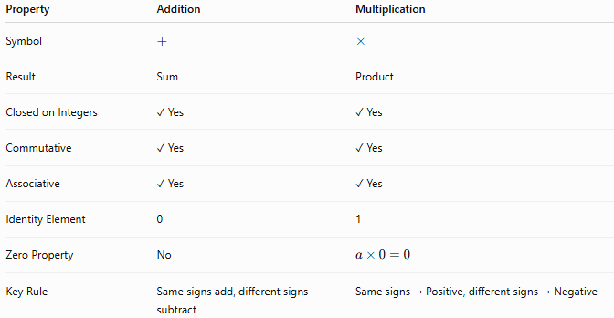
Property | Addition | Multiplication
Symbol | $$+$$ | $$×$$
Result | Sum | Product
Closed on Integers | ✓ Yes | ✓ Yes
Commutative | ✓ Yes | ✓ Yes
Associative | ✓ Yes | ✓ Yes
Identity Element | 0 | 1
Zero Property | No | $$a×0=0$$
Key Rule | Same signs add, different signs subtract | Same signs → Positive, different signs → Negative

Conclusion
# Source: AI Source: Provided by: [Data Path: Persons Table -> ID Column: 1, Name_En Column: Motasem Essam] -> From: [ChatGPT] on [7/11/2026]
Multiplication of signed numbers extends ordinary multiplication by incorporating positive and negative values. The operation is performed by multiplying the absolute values of the numbers and then applying the appropriate sign rule: same signs produce a positive result, while different signs produce a negative result. Signed number multiplication is fundamental in algebra and has numerous applications in finance, physics, engineering, computer programming, and everyday situations involving direction, gains, losses, and changes.

Division
# Source: AI Source: Provided by: [Data Path: Persons Table -> ID Column: 1, Name_En Column: Motasem Essam] -> From: [ChatGPT] on [7/11/2026]
Division of signed numbers is the arithmetic operation of determining the quotient of two numbers that may be positive (+), negative (−), or zero (0).
Like signed number multiplication, signed number division requires applying sign rules in addition to dividing the absolute values of the numbers.

Definition
# Source: AI Source: Provided by: [Data Path: Persons Table -> ID Column: 1, Name_En Column: Motasem Essam] -> From: [ChatGPT] on [7/11/2026]
Signed number division is the process of dividing two signed numbers by dividing their absolute values and determining the sign of the result according to the rules of signs.
Mathematically:
$$a÷b=q$$
or
$$\frac{a}{b}=q$$
where:
- $a$is the dividend.
- $b$is the divisor.
- $q$is the quotient.
Signed number division is commonly performed on the set of integers ($Z$), provided the divisor is not zero.

Division Symbols
# Source: AI Source: Provided by: [Data Path: Persons Table -> ID Column: 1, Name_En Column: Motasem Essam] -> From: [ChatGPT] on [7/11/2026]
Common symbols for division include:
$$÷,/,\frac{a}{b}$$
Example:
$$(-24)÷6=-4$$

Rules for Dividing Signed Numbers

1. Positive ÷ Positive
# Source: AI Source: Provided by: [Data Path: Persons Table -> ID Column: 1, Name_En Column: Motasem Essam] -> From: [ChatGPT] on [7/11/2026]
Divide the absolute values.
The result is positive.
$$\left(+a)÷(+b)=+(a÷b\right)$$
Example:
$$(+20)÷(+5)=+4$$

2. Negative ÷ Negative
# Source: AI Source: Provided by: [Data Path: Persons Table -> ID Column: 1, Name_En Column: Motasem Essam] -> From: [ChatGPT] on [7/11/2026]
Divide the absolute values.
The result is positive.
$$\left(-a)÷(-b)=+(a÷b\right)$$
Example:
$$(-36)÷(-6)=+6$$

3. Positive ÷ Negative
# Source: AI Source: Provided by: [Data Path: Persons Table -> ID Column: 1, Name_En Column: Motasem Essam] -> From: [ChatGPT] on [7/11/2026]
Divide the absolute values.
The result is negative.
$$\left(+a)÷(-b)=-(a÷b\right)$$
Example:
$$(+42)÷(-7)=-6$$

4. Negative ÷ Positive
# Source: AI Source: Provided by: [Data Path: Persons Table -> ID Column: 1, Name_En Column: Motasem Essam] -> From: [ChatGPT] on [7/11/2026]
Divide the absolute values.
The result is negative.
$$\left(-a)÷(+b)=-(a÷b\right)$$
Example:
$$(-45)÷(+9)=-5$$

Sign Rule Summary
# Source: AI Source: Provided by: [Data Path: Persons Table -> ID Column: 1, Name_En Column: Motasem Essam] -> From: [ChatGPT] on [7/11/2026]
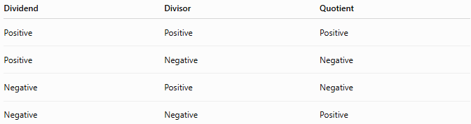
Dividend | Divisor | Quotient
Positive | Positive | Positive
Positive | Negative | Negative
Negative | Positive | Negative
Negative | Negative | Positive
A simple memory aid:
- Same signs → Positive
- Different signs → Negative

Division by Zero
# Source: AI Source: Provided by: [Data Path: Persons Table -> ID Column: 1, Name_En Column: Motasem Essam] -> From: [ChatGPT] on [7/11/2026]
Division by zero is undefined.
$$a÷0$$
has no mathematical meaning.
Examples:
$$15÷0$$
Undefined
$$0÷0$$
Also undefined.

Zero Dividend Property
Zero divided by any nonzero number equals zero.
$$0÷a=0(a≠0)$$
Example:
$$0÷(-8)=0$$

Examples
# Source: AI Source: Provided by: [Data Path: Persons Table -> ID Column: 1, Name_En Column: Motasem Essam] -> From: [ChatGPT] on [7/11/2026]
Example 1
$$(+48)÷(+6)=8$$

Example 2
$$(-56)÷(+7)=-8$$

Example 3
$$(+81)÷(-9)=-9$$

Example 4
$$(-72)÷(-8)=9$$

Example 5
$$0÷15=0$$

Example 6
$$(-120)÷(+10)=-12$$

Long Division
# Source: AI Source: Provided by: [Data Path: Persons Table -> ID Column: 1, Name_En Column: Motasem Essam] -> From: [ChatGPT] on [7/11/2026]
Example:
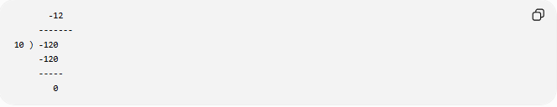
-12
-------
10 ) -120
-120
-----
0
Calculation:
$$(-120)÷10=-12$$

Example:
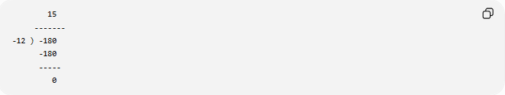
15
-------
-12 ) -180
-180
-----
0
Calculation:
$$(-180)÷(-12)=15$$

Properties of Signed Number Division
# Source: AI Source: Provided by: [Data Path: Persons Table -> ID Column: 1, Name_En Column: Motasem Essam] -> From: [ChatGPT] on [7/11/2026]
Let $a$, $b$, and $c$be integers, where $b≠0$.

1. Not Closed on Integers
# Source: AI Source: Provided by: [Data Path: Persons Table -> ID Column: 1, Name_En Column: Motasem Essam] -> From: [ChatGPT] on [7/11/2026]
Division of two integers is not always an integer.
$$a,b∈Z⇏a÷b∈Z$$
Example:
$$7÷2=3.5$$
Since 3.5 is not an integer, division is not closed on integers.

2. Not Commutative
# Source: AI Source: Provided by: [Data Path: Persons Table -> ID Column: 1, Name_En Column: Motasem Essam] -> From: [ChatGPT] on [7/11/2026]
Changing the order changes the result.
$$a÷b≠b÷a$$
Example:
$$20÷5=4$$
but
$$5÷20=\frac{1}{4}$$

3. Not Associative
# Source: AI Source: Provided by: [Data Path: Persons Table -> ID Column: 1, Name_En Column: Motasem Essam] -> From: [ChatGPT] on [7/11/2026]
Changing the grouping changes the result.
$$\left(a÷b)÷c≠a÷(b÷c\right)$$
Example:
$$(24÷6)÷2=2$$
but
$$24÷(6÷2)=8$$

4. Identity Property
# Source: AI Source: Provided by: [Data Path: Persons Table -> ID Column: 1, Name_En Column: Motasem Essam] -> From: [ChatGPT] on [7/11/2026]
Dividing by 1 leaves the number unchanged.
$$a÷1=a$$
Example:
$$(-64)÷1=-64$$

5. Division by Itself
# Source: AI Source: Provided by: [Data Path: Persons Table -> ID Column: 1, Name_En Column: Motasem Essam] -> From: [ChatGPT] on [7/11/2026]
Every nonzero integer divided by itself equals one.
$$a÷a=1(a≠0)$$
Example:
$$(-25)÷(-25)=1$$

Checking Division
# Source: AI Source: Provided by: [Data Path: Persons Table -> ID Column: 1, Name_En Column: Motasem Essam] -> From: [ChatGPT] on [7/11/2026]
Division can be verified using multiplication.
Example:
$$(-72)÷9=-8$$
Check:
$$(-8)×9=-72$$
Since the original dividend is obtained, the division is correct.

Real-Life Applications
# Source: AI Source: Provided by: [Data Path: Persons Table -> ID Column: 1, Name_En Column: Motasem Essam] -> From: [ChatGPT] on [7/11/2026]
Division of signed numbers is used in:
- Financial calculations
- Average gains and losses
- Physics (velocity and acceleration)
- Temperature change rates
- Accounting
- Engineering
- Computer programming
- Scientific measurements

Real-Life Examples
# Source: AI Source: Provided by: [Data Path: Persons Table -> ID Column: 1, Name_En Column: Motasem Essam] -> From: [ChatGPT] on [7/11/2026]
1. Average Financial Loss
A company loses 240 dollars over 6 days.
Average daily loss:
$$(-240)÷6=-40$$
The average loss is 40 dollars per day.

2. Temperature Change
The temperature decreases by 24°C over 8 hours.
Average hourly change:
$$(-24)÷8=-3$$
The temperature changes by −3°C per hour.

3. Elevator Movement
An elevator descends 30 floors in 6 equal intervals.
$$(-30)÷6=-5$$
Each interval represents a movement of 5 floors downward.

4. Business Accounting
A business records a total loss of −900 dollars over 9 months.
Average monthly loss:
$$(-900)÷9=-100$$
The average loss is 100 dollars per month.

5. Stock Market
A stock loses 60 points over 12 trading days.
Average daily change:
$$(-60)÷12=-5$$
The average change is −5 points per day.

6. Coordinate Geometry
A movement of −48 units is completed in 6 equal steps.
$$(-48)÷6=-8$$
Each step is −8 units.

7. Sharing Debt
A debt of −200 dollars is shared equally among 4 people.
$$(-200)÷4=-50$$
Each person is responsible for 50 dollars of debt.

8. Physics
A velocity changes by −90 m/s over 9 seconds.
Average rate of change:
$$(-90)÷9=-10$$
The average acceleration is −10 m/s².

Common Mistakes
# Source: AI Source: Provided by: [Data Path: Persons Table -> ID Column: 1, Name_En Column: Motasem Essam] -> From: [ChatGPT] on [7/11/2026]
- Forgetting the sign rules.
- Dividing by zero.
- Assuming division is commutative.
- Confusing the quotient with the remainder.
- Assuming integer division always produces an integer.

Key Points
# Source: AI Source: Provided by: [Data Path: Persons Table -> ID Column: 1, Name_En Column: Motasem Essam] -> From: [ChatGPT] on [7/11/2026]
- Divide the absolute values first.
- Apply the sign rules afterward.
- Same signs → Positive.
- Different signs → Negative.
- Division by 1 leaves the number unchanged.
- Division by 0 is undefined.
- Zero divided by any nonzero number equals 0.
- Signed number division is not closed on the set of integers.
- Division is not commutative and not associative.

Signed Number Multiplication vs. Signed Number Division
# Source: AI Source: Provided by: [Data Path: Persons Table -> ID Column: 1, Name_En Column: Motasem Essam] -> From: [ChatGPT] on [7/11/2026]
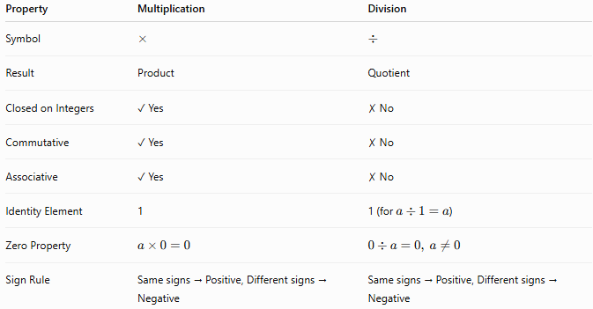
Property | Multiplication | Division
Symbol | $$×$$ | $$÷$$
Result | Product | Quotient
Closed on Integers | ✓ Yes | ✗ No
Commutative | ✓ Yes | ✗ No
Associative | ✓ Yes | ✗ No
Identity Element | 1 | 1 (for $a÷1=a$)
Zero Property | $$a×0=0$$ | $$0÷a=0, a≠0$$
Sign Rule | Same signs → Positive, Different signs → Negative | Same signs → Positive, Different signs → Negative

Conclusion
# Source: AI Source: Provided by: [Data Path: Persons Table -> ID Column: 1, Name_En Column: Motasem Essam] -> From: [ChatGPT] on [7/11/2026]
Division of signed numbers extends ordinary division by incorporating positive and negative values. The operation is performed by dividing the absolute values of the numbers and then applying the sign rule: same signs produce a positive quotient, while different signs produce a negative quotient. Signed number division is an essential operation in algebra and has many practical applications in finance, physics, engineering, computer science, and everyday situations involving rates, averages, gains, losses, and directional changes.

Modulus
# Source: AI Source: Provided by: [Data Path: Persons Table -> ID Column: 1, Name_En Column: Motasem Essam] -> From: [ChatGPT] on [7/11/2026]
Modulus (or the modulo operation) with signed numbers finds the remainder after dividing one integer by another integer. It extends the modulus operation from whole numbers to include positive and negative integers.
The modulus operation is commonly used in mathematics, computer science, programming, cryptography, calendars, clocks, and cyclic calculations.

Definition
# Source: AI Source: Provided by: [Data Path: Persons Table -> ID Column: 1, Name_En Column: Motasem Essam] -> From: [ChatGPT] on [7/11/2026]
For integers $a$and $b$with $b≠0$, the modulus operation returns the remainder $r$after dividing $a$by $b$.
Mathematically:
$$a mod b=r$$
where:
- $a$is the dividend
- $b$is the divisor
- $r$is the remainder
The division relationship is:
$$a=bq+r$$
where:
- $q$is the quotient
- $r$is the remainder
For standard mathematical modulus with a positive divisor:
$$0≤r<b$$

Modulus Symbols
# Source: AI Source: Provided by: [Data Path: Persons Table -> ID Column: 1, Name_En Column: Motasem Essam] -> From: [ChatGPT] on [7/11/2026]
The modulus operation is written as:
$$a mod b$$
In many programming languages, it is written using the percent symbol:
a % b
Example:
$$17 mod 5=2$$
because
$$17=5×3+2$$

Modulus with Positive Numbers
# Source: AI Source: Provided by: [Data Path: Persons Table -> ID Column: 1, Name_En Column: Motasem Essam] -> From: [ChatGPT] on [7/11/2026]
When both numbers are positive, modulus works the same as ordinary remainder.
Example:
$$23 mod 6$$
Divide 23 by 6:
$$23=6×3+5$$
Therefore:
$$23 mod 6=5$$

Modulus with Negative Numbers
# Source: AI Source: Provided by: [Data Path: Persons Table -> ID Column: 1, Name_En Column: Motasem Essam] -> From: [ChatGPT] on [7/11/2026]
For signed numbers, the modulus result depends on the quotient and remainder relationship.
A common mathematical convention is:
- The remainder has the same sign as the divisor.
- If the divisor is positive, the remainder is nonnegative.
- If the divisor is negative, the remainder is nonpositive.

Examples
# Source: AI Source: Provided by: [Data Path: Persons Table -> ID Column: 1, Name_En Column: Motasem Essam] -> From: [ChatGPT] on [7/11/2026]
Example 1: Positive dividend, positive divisor
$$17 mod 5$$
$$17=5×3+2$$
Result:
$$17 mod 5=2$$
Example 2: Negative dividend, positive divisor
$$-17 mod 5$$
We need a quotient so that the remainder is between 0 and 4.
$$-17=5×(-4)+3$$
Result:
$$-17 mod 5=3$$
Example 3: Positive dividend, negative divisor
$$17 mod (-5)$$
Choose the quotient so the remainder has the same sign as the divisor.
$$17=(-5)×(-3)+2$$
Since the divisor is negative, we adjust:
$$17=(-5)×(-4)+(-3)$$
Result:
$$17 mod (-5)=-3$$
Example 4: Negative dividend, negative divisor
$$-17 mod (-5)$$
$$-17=(-5)×3+(-2)$$
Result:
$$-17 mod (-5)=-2$$
Example 5: Exact division
$$-24 mod 6$$
$$-24=6×(-4)+0$$
Result:
$$-24 mod 6=0$$
Example 6: Another negative dividend
$$-35 mod 6$$
$$-35=6×(-6)+1$$
Result:
$$-35 mod 6=1$$

Signed Modulus Table
# Source: AI Source: Provided by: [Data Path: Persons Table -> ID Column: 1, Name_En Column: Motasem Essam] -> From: [ChatGPT] on [7/11/2026]
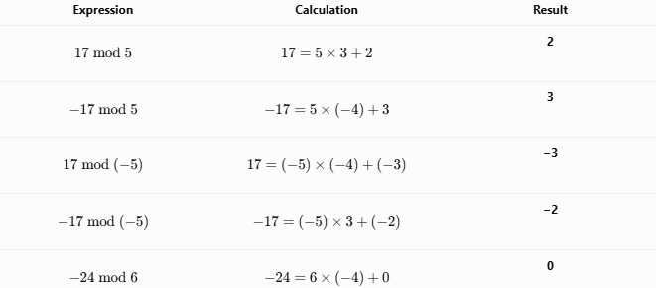
Expression | Calculation | Result
$$17 mod 5$$ | $$17=5×3+2$$ | 2
$$-17 mod 5$$ | $$-17=5×(-4)+3$$ | 3
$$17 mod (-5)$$ | $$17=(-5)×(-4)+(-3)$$ | −3
$$-17 mod (-5)$$ | $$-17=(-5)×3+(-2)$$ | −2
$$-24 mod 6$$ | $$-24=6×(-4)+0$$ | 0

Properties of Signed Modulus

1. Division Relationship
# Source: AI Source: Provided by: [Data Path: Persons Table -> ID Column: 1, Name_En Column: Motasem Essam] -> From: [ChatGPT] on [7/11/2026]
$$a=bq+r$$
where $r=a mod b$.

2. Remainder Range
# Source: AI Source: Provided by: [Data Path: Persons Table -> ID Column: 1, Name_En Column: Motasem Essam] -> From: [ChatGPT] on [7/11/2026]
If the divisor is positive:
$$0≤r<b$$
Example:
$$-17 mod 5=3$$

3. Divisibility Property
# Source: AI Source: Provided by: [Data Path: Persons Table -> ID Column: 1, Name_En Column: Motasem Essam] -> From: [ChatGPT] on [7/11/2026]
If a number is divisible by another number, the remainder is zero.
$$a mod b=0$$
Example:
$$-36 mod 6=0$$

4. Modulus by One
# Source: AI Source: Provided by: [Data Path: Persons Table -> ID Column: 1, Name_En Column: Motasem Essam] -> From: [ChatGPT] on [7/11/2026]
Every integer divided by 1 leaves remainder 0.
$$a mod 1=0$$
Example:
$$-57 mod 1=0$$

5. Modulus by Itself
# Source: AI Source: Provided by: [Data Path: Persons Table -> ID Column: 1, Name_En Column: Motasem Essam] -> From: [ChatGPT] on [7/11/2026]
Any nonzero integer divided by itself leaves remainder 0.
$$a mod a=0(a≠0)$$
Example:
$$-25 mod (-25)=0$$

6. Modulus by Zero
# Source: AI Source: Provided by: [Data Path: Persons Table -> ID Column: 1, Name_En Column: Motasem Essam] -> From: [ChatGPT] on [7/11/2026]
Modulus by zero is undefined.
$$a mod 0$$
has no mathematical meaning.

Relationship Between Division and Modulus
# Source: AI Source: Provided by: [Data Path: Persons Table -> ID Column: 1, Name_En Column: Motasem Essam] -> From: [ChatGPT] on [7/11/2026]
For signed numbers:
$$a=bq+r$$
where $r=a mod b$.
Example
$$-29 mod 6$$
$$-29=6×(-5)+1$$
Therefore:
$$-29 mod 6=1$$
The quotient is −5 and the remainder is 1.

Real-Life Applications
# Source: AI Source: Provided by: [Data Path: Persons Table -> ID Column: 1, Name_En Column: Motasem Essam] -> From: [ChatGPT] on [7/11/2026]
Signed modulus is used in:
- Computer programming
- Circular counting
- Digital clocks
- Calendars
- Cryptography
- Hash functions
- Game development
- Coordinate systems
- Signal processing
- Number theory

Real-Life Examples
# Source: AI Source: Provided by: [Data Path: Persons Table -> ID Column: 1, Name_En Column: Motasem Essam] -> From: [ChatGPT] on [7/11/2026]
1. Even or Odd Numbers
To determine whether a signed integer is even:
$$n mod 2$$
Example:
$$-14 mod 2=0$$
Therefore, −14 is even.
Example:
$$-15 mod 2=1$$
Therefore, −15 is odd.

2. Digital Clock
A 12-hour clock repeats every 12 hours.
Moving backward 5 hours from 2 o’clock:
$$-5 mod 12=7$$
The clock wraps around to 7 o’clock.

3. Days of the Week
The days repeat every 7 days.
Moving backward 3 days:
$$-3 mod 7=4$$
The result corresponds to moving forward 4 days in the weekly cycle.

4. Circular Seating
There are 10 seats around a circular table.
Moving backward 7 seats from seat 2:
$$-7 mod 10=3$$
The position wraps around to seat 3.

5. Computer Programming
Programmers use modulus to keep array indices within bounds.
(-1) % 5 = 4
This wraps index −1 to index 4 in a 5-element array.

6. Game Development
When an object moves left past the screen boundary, modulus can wrap it to the other side.

7. Coordinate Systems
Negative rotations can be converted into equivalent positive rotations.
$$-90 mod 360=270$$
A rotation of −90° is equivalent to 270°.

8. Cryptography
Modular arithmetic with signed integers is used in encryption algorithms such as RSA.

Common Mistakes
# Source: AI Source: Provided by: [Data Path: Persons Table -> ID Column: 1, Name_En Column: Motasem Essam] -> From: [ChatGPT] on [7/11/2026]
- Confusing modulus with ordinary division.
- Forgetting that modulus returns the remainder, not the quotient.
- Ignoring the sign convention for negative numbers.
- Assuming all programming languages handle negative modulus the same way.
- Using modulus with a divisor of zero.
- Confusing the modulus operator % with the percentage symbol %.

Key Points
# Source: AI Source: Provided by: [Data Path: Persons Table -> ID Column: 1, Name_En Column: Motasem Essam] -> From: [ChatGPT] on [7/11/2026]
- Modulus returns the remainder after integer division.
- For signed numbers, the result depends on the quotient and divisor.
- With a positive divisor, the remainder is nonnegative.
- If the remainder is 0, the dividend is divisible by the divisor.
- Modulus by 0 is undefined.
- Signed modulus is important in cyclic calculations, programming, cryptography, and number theory.

Signed Division vs. Signed Modulus
# Source: AI Source: Provided by: [Data Path: Persons Table -> ID Column: 1, Name_En Column: Motasem Essam] -> From: [ChatGPT] on [7/11/2026]
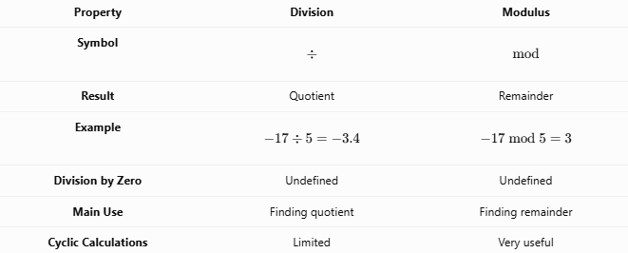
Property | Division | Modulus
Symbol | $$÷$$ | $$mod$$
Result | Quotient | Remainder
Example | $$-17÷5=-3.4$$ | $$-17 mod 5=3$$
Division by Zero | Undefined | Undefined
Main Use | Finding quotient | Finding remainder
Cyclic Calculations | Limited | Very useful

Conclusion
# Source: AI Source: Provided by: [Data Path: Persons Table -> ID Column: 1, Name_En Column: Motasem Essam] -> From: [ChatGPT] on [7/11/2026]
Signed modulus (modulo) extends the remainder operation to include both positive and negative integers. It is defined through the relationship $a=bq+r$, where $r$is the remainder. With a positive divisor, the remainder is always nonnegative and less than the divisor. Signed modulus is an essential concept in mathematics, computer science, cryptography, calendars, clocks, coordinate systems, and many applications involving repeating or cyclic patterns.

Exponentiation (Power)
# Source: AI Source: Provided by: [Data Path: Persons Table -> ID Column: 1, Name_En Column: Motasem Essam] -> From: [ChatGPT] on [7/11/2026]
Exponentiation (or raising to a power) is the arithmetic operation of multiplying a number, called the base, by itself repeatedly according to an integer exponent. When signed numbers are used, the sign of the result depends on the sign of the base and whether the exponent is even or odd.
Exponentiation is widely used in algebra, geometry, science, engineering, finance, computer science, and many other areas of mathematics.

Definition
# Source: AI Source: Provided by: [Data Path: Persons Table -> ID Column: 1, Name_En Column: Motasem Essam] -> From: [ChatGPT] on [7/11/2026]
Signed number exponentiation is the process of raising a signed number to an integer power.
Mathematically,
$$a^{n}$$
where:
- $a$is the base (may be positive, negative, or zero).
- $n$is the exponent (a whole number or integer).
- $a^{n}$is the power.
For positive integer exponents,
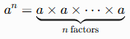
$$a^{n}=\underset{n\text{ factors}}{\underset{⏟}{a×a×⋯×a}}$$

Exponentiation Symbols
# Source: AI Source: Provided by: [Data Path: Persons Table -> ID Column: 1, Name_En Column: Motasem Essam] -> From: [ChatGPT] on [7/11/2026]
Common notations include:
$$a^{n}$$
Example:
$$\left(-3)^{4}=81\right.$$

Rules for Exponentiation with Signed Numbers

1. Positive Base
# Source: AI Source: Provided by: [Data Path: Persons Table -> ID Column: 1, Name_En Column: Motasem Essam] -> From: [ChatGPT] on [7/11/2026]
A positive number raised to any whole-number exponent remains positive.
$$\left(+a)^{n}=+a^{n}\right.$$
Example:
$$\left(+4)^{3}=64\right.$$

2. Negative Base with an Even Exponent
# Source: AI Source: Provided by: [Data Path: Persons Table -> ID Column: 1, Name_En Column: Motasem Essam] -> From: [ChatGPT] on [7/11/2026]
A negative number raised to an even exponent gives a positive result.
$$\left(-a)^{2n}=+a^{2n}\right.$$
Example:
$$\left(-5)^{2}=25\right.$$

Example:
$$\left(-2)^{6}=64\right.$$

3. Negative Base with an Odd Exponent
# Source: AI Source: Provided by: [Data Path: Persons Table -> ID Column: 1, Name_En Column: Motasem Essam] -> From: [ChatGPT] on [7/11/2026]
A negative number raised to an odd exponent gives a negative result.
$$\left(-a)^{2n+1}=-a^{2n+1}\right.$$
Example:
$$\left(-4)^{3}=-64\right.$$

Example:
$$\left(-2)^{5}=-32\right.$$

4. Zero as the Base
# Source: AI Source: Provided by: [Data Path: Persons Table -> ID Column: 1, Name_En Column: Motasem Essam] -> From: [ChatGPT] on [7/11/2026]
For every positive exponent,
$$0^{n}=0(n>0)$$
Example:
$$0^{6}=0$$

5. Exponent Zero
# Source: AI Source: Provided by: [Data Path: Persons Table -> ID Column: 1, Name_En Column: Motasem Essam] -> From: [ChatGPT] on [7/11/2026]
Every nonzero number raised to the zero power equals one.
$$a^{0}=1(a≠0)$$
Examples:
$$\left(-8)^{0}=1\right. \\ 5^{0}=1$$

6. Negative Exponents
# Source: AI Source: Provided by: [Data Path: Persons Table -> ID Column: 1, Name_En Column: Motasem Essam] -> From: [ChatGPT] on [7/11/2026]
A negative exponent gives the reciprocal of the corresponding positive power.
$$a^{-n}=\frac{1}{a^{n}}(a≠0)$$
Examples:
$$2^{-3}=\frac{1}{8} \\ \left(-2)^{-2}=\frac{1}{4}\right.$$

Parentheses Matter
# Source: AI Source: Provided by: [Data Path: Persons Table -> ID Column: 1, Name_En Column: Motasem Essam] -> From: [ChatGPT] on [7/11/2026]
The position of parentheses changes the result.
Example:
$$\left(-3)^{2}=9\right.$$
because the entire negative number is squared.
However,
$$-3^{2}=-9$$
because the exponent applies only to 3, and the negative sign is applied afterward.

Examples
# Source: AI Source: Provided by: [Data Path: Persons Table -> ID Column: 1, Name_En Column: Motasem Essam] -> From: [ChatGPT] on [7/11/2026]
Example 1
$$\left(+6)^{2}=36\right.$$

Example 2
$$\left(-5)^{2}=25\right.$$

Example 3
$$\left(-5)^{3}=-125\right.$$

Example 4
$$\left(-2)^{6}=64\right.$$

Example 5
$$7^{0}=1$$

Example 6
$$\left(-3)^{4}=81\right.$$

Exponentiation Table
# Source: AI Source: Provided by: [Data Path: Persons Table -> ID Column: 1, Name_En Column: Motasem Essam] -> From: [ChatGPT] on [7/11/2026]
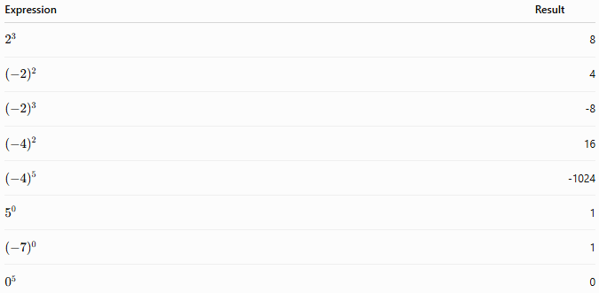
Expression | Result
$$2^{3}$$ | 8
$${\left(-2\right)}^{2}$$ | 4
$${\left(-2\right)}^{3}$$ | -8
$${\left(-4\right)}^{2}$$ | 16
$${\left(-4\right)}^{5}$$ | -1024
$$5^{0}$$ | 1
$${\left(-7\right)}^{0}$$ | 1
$$0^{5}$$ | 0

Properties of Signed Number Exponentiation
# Source: AI Source: Provided by: [Data Path: Persons Table -> ID Column: 1, Name_En Column: Motasem Essam] -> From: [ChatGPT] on [7/11/2026]
Let $a$and $b$be signed numbers, and let $m$and $n$be integers.

1. Product of Powers
# Source: AI Source: Provided by: [Data Path: Persons Table -> ID Column: 1, Name_En Column: Motasem Essam] -> From: [ChatGPT] on [7/11/2026]
$$a^{m}×a^{n}=a^{m+n}$$
Example:
$$2^{3}×2^{4}=2^{7}=128$$

2. Quotient of Powers
# Source: AI Source: Provided by: [Data Path: Persons Table -> ID Column: 1, Name_En Column: Motasem Essam] -> From: [ChatGPT] on [7/11/2026]
$$\frac{a^{m}}{a^{n}}=a^{m-n}(a≠0)$$
Example:
$$\frac{5^{6}}{5^{2}}=5^{4}=625$$

3. Power of a Power
# Source: AI Source: Provided by: [Data Path: Persons Table -> ID Column: 1, Name_En Column: Motasem Essam] -> From: [ChatGPT] on [7/11/2026]
$$\left(a^{m})^{n} = a^{mn}\right.$$
Example:
$$\left((-2)^{2})^{3}=(-2)^{6}=64\right.$$

4. Power of a Product
# Source: AI Source: Provided by: [Data Path: Persons Table -> ID Column: 1, Name_En Column: Motasem Essam] -> From: [ChatGPT] on [7/11/2026]
$$\left(ab)^{n} = a^{n}b^{n}\right.$$
Example:
$$\left(-2×3)^{2}=(-2)^{2}×3^{2}=36\right.$$

5. Power of a Quotient
# Source: AI Source: Provided by: [Data Path: Persons Table -> ID Column: 1, Name_En Column: Motasem Essam] -> From: [ChatGPT] on [7/11/2026]
$${\left(\frac{a}{b}\right)}^{n}=\frac{a^{n}}{b^{n}}(b≠0)$$
Example:
$${\left(\frac{-4}{2}\right)}^{3}=\frac{{\left(-4\right)}^{3}}{2^{3}}=-8$$

Checking Exponentiation
# Source: AI Source: Provided by: [Data Path: Persons Table -> ID Column: 1, Name_En Column: Motasem Essam] -> From: [ChatGPT] on [7/11/2026]
Exponentiation can be verified using repeated multiplication.
Example:
$$(-3)^{4}=(-3)×(-3)×(-3)×(-3)=81$$

Real-Life Applications
# Source: AI Source: Provided by: [Data Path: Persons Table -> ID Column: 1, Name_En Column: Motasem Essam] -> From: [ChatGPT] on [7/11/2026]
Signed number exponentiation is used in:
- Algebra
- Scientific calculations
- Computer science
- Engineering
- Finance
- Physics
- Population growth models
- Coordinate geometry

Real-Life Examples
# Source: AI Source: Provided by: [Data Path: Persons Table -> ID Column: 1, Name_En Column: Motasem Essam] -> From: [ChatGPT] on [7/11/2026]
1. Area Calculation
The area of a square with side length −5 units is:
$$\left(-5)^{2}=25\right.$$
The area is 25 square units.

2. Physics
A velocity of −8 m/s is squared when computing kinetic energy.
$$\left(-8)^{2}=64\right.$$
The squared velocity is positive.

3. Computer Science
Memory capacities are commonly powers of two.
$$2^{10}=1024$$
One kilobyte is approximately 1024 bytes.

4. Finance
Compound growth formulas use exponents to model investment growth over time.

5. Population Growth
Scientists model exponential population growth using powers.

6. Geometry
The volume of a cube depends on the third power of its side length.
$$s^{3}$$

7. Signal Processing
Engineers use squared values when calculating signal power and energy.

8. Coordinate Geometry
The distance formula involves squaring positive and negative coordinate differences.
$$\left(-7)^{2}=49\right.$$

Common Mistakes
# Source: AI Source: Provided by: [Data Path: Persons Table -> ID Column: 1, Name_En Column: Motasem Essam] -> From: [ChatGPT] on [7/11/2026]
- Forgetting parentheses around a negative base.
- Assuming a negative base always gives a negative result.
- Confusing
$${\left(-3\right)}^{2}$$
with
$$-3^{2}$$
- Believing
$$0^{0}=1$$
In elementary mathematics, $0^{0}$is generally considered undefined or left undefined.
- Ignoring the even/odd exponent rule.

Key Points
# Source: AI Source: Provided by: [Data Path: Persons Table -> ID Column: 1, Name_En Column: Motasem Essam] -> From: [ChatGPT] on [7/11/2026]
- Exponentiation is repeated multiplication.
- A positive base always gives a positive result.
- A negative base raised to an even exponent gives a positive result.
- A negative base raised to an odd exponent gives a negative result.
- Every nonzero number raised to the zero power equals 1.
- Zero raised to any positive exponent equals 0.
- Parentheses are essential when the base is negative.
- Exponentiation satisfies the product, quotient, and power laws.

Signed Number Multiplication vs. Signed Number Exponentiation
# Source: AI Source: Provided by: [Data Path: Persons Table -> ID Column: 1, Name_En Column: Motasem Essam] -> From: [ChatGPT] on [7/11/2026]
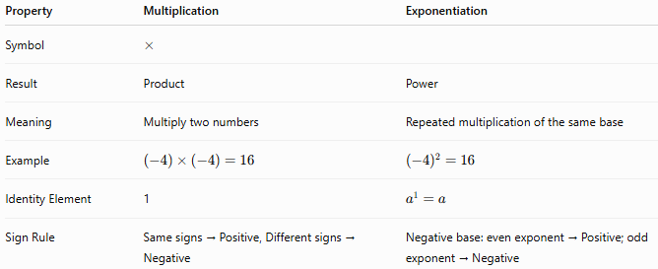
Property | Multiplication | Exponentiation
Symbol | $$×$$
Result | Product | Power
Meaning | Multiply two numbers | Repeated multiplication of the same base
Example | $$(-4)×(-4)=16$$ | $$\left(-4)^{2}=16\right.$$
Identity Element | 1 | $$a^{1}=a$$
Sign Rule | Same signs → Positive, Different signs → Negative | Negative base: even exponent → Positive; odd exponent → Negative

Conclusion
# Source: AI Source: Provided by: [Data Path: Persons Table -> ID Column: 1, Name_En Column: Motasem Essam] -> From: [ChatGPT] on [7/11/2026]
Exponentiation of signed numbers extends ordinary exponentiation by allowing positive and negative bases. The magnitude of the result is obtained through repeated multiplication, while the sign depends on the parity of the exponent: a negative base raised to an even exponent produces a positive result, and a negative base raised to an odd exponent produces a negative result. Signed exponentiation is fundamental in algebra, geometry, science, engineering, finance, and computer science, where powers are used to model growth, measure areas and volumes, and solve complex mathematical problems.

Root (Radical)
# Source: AI Source: Provided by: [Data Path: Persons Table -> ID Column: 1, Name_En Column: Motasem Essam] -> From: [ChatGPT] on [7/11/2026]
The root (or radical) operation is the inverse of exponentiation. It determines the number that, when raised to a given power, produces the original number.
When working with signed numbers, the existence and sign of a root depend on whether the index (degree) of the root is positive, negative, even, or odd, and whether the radicand is positive, negative, or zero.

Definition
# Source: AI Source: Provided by: [Data Path: Persons Table -> ID Column: 1, Name_En Column: Motasem Essam] -> From: [ChatGPT] on [7/11/2026]
A root of a signed number is a value that, when raised to a specified power, equals the original number.
Mathematically,
$$\sqrt[n]{a}=b$$
if and only if
$$b^{n}=a$$
where:
- $a$is the radicand
- $n$is the index (degree) of the root
- $b$is the root

Radical Symbols
# Source: AI Source: Provided by: [Data Path: Persons Table -> ID Column: 1, Name_En Column: Motasem Essam] -> From: [ChatGPT] on [7/11/2026]
Square root:
$$\sqrt{a}$$
Cube root:
$$\sqrt[3]{a}$$
General nth root:
$$\sqrt[n]{a}$$
Examples:
$$\sqrt{49}=7 \\ \sqrt[3]{-27}=-3$$

Rules for Roots of Signed Numbers

1. Square Root of a Positive Number
# Source: AI Source: Provided by: [Data Path: Persons Table -> ID Column: 1, Name_En Column: Motasem Essam] -> From: [ChatGPT] on [7/11/2026]
A positive number has two square roots.
$$x^{2}=a$$
Example:
$$x^{2}=25$$
Solutions:
$$x=±5$$
However, the principal square root is
$$\sqrt{25}=5$$

2. Square Root of Zero
# Source: AI Source: Provided by: [Data Path: Persons Table -> ID Column: 1, Name_En Column: Motasem Essam] -> From: [ChatGPT] on [7/11/2026]
$$\sqrt{0}=0$$
Example:
$$\sqrt{0}=0$$

3. Square Root of a Negative Number
# Source: AI Source: Provided by: [Data Path: Persons Table -> ID Column: 1, Name_En Column: Motasem Essam] -> From: [ChatGPT] on [7/11/2026]
There is no real square root of a negative number.
Example:
$$\sqrt{-16}$$
is not defined in the real numbers.
In the complex number system,
$$\sqrt{-16}=4i$$
where
$$i=\sqrt{-1}$$

4. Cube Root of a Positive Number
# Source: AI Source: Provided by: [Data Path: Persons Table -> ID Column: 1, Name_En Column: Motasem Essam] -> From: [ChatGPT] on [7/11/2026]
$$\sqrt[3]{64}=4$$
because
$$4^{3}=64$$

5. Cube Root of a Negative Number
# Source: AI Source: Provided by: [Data Path: Persons Table -> ID Column: 1, Name_En Column: Motasem Essam] -> From: [ChatGPT] on [7/11/2026]
Odd roots preserve the sign.
$$\sqrt[3]{-125}=-5$$
because
$$\left(-5)^{3}=-125\right.$$

6. Even Roots
# Source: AI Source: Provided by: [Data Path: Persons Table -> ID Column: 1, Name_En Column: Motasem Essam] -> From: [ChatGPT] on [7/11/2026]
Even roots of negative numbers do not exist in the real numbers.
Example:
$$\sqrt[4]{-81}$$
has no real value.

7. Odd Roots
# Source: AI Source: Provided by: [Data Path: Persons Table -> ID Column: 1, Name_En Column: Motasem Essam] -> From: [ChatGPT] on [7/11/2026]
Odd roots always exist for every real number.
Examples:
$$\sqrt[3]{-8}=-2 \\ \sqrt[5]{-32}=-2$$

8. Negative Root Index (Negative Radical Degree)
# Source: AI Source: Provided by: [Data Path: Persons Table -> ID Column: 1, Name_En Column: Motasem Essam] -> From: [ChatGPT] on [7/11/2026]
Although negative radical indices are not standard mathematical notation, they can be interpreted using negative fractional exponents.
General formula:
$$\sqrt[-n]{a}=a^{-\frac{1}{n}}=\frac{1}{\sqrt[n]{a}}$$
provided the root exists and is not zero.
Examples
$$\sqrt[-2]{25}=\frac{1}{\sqrt{25}}=\frac{1}{5}$$
$$\sqrt[-3]{27}=\frac{1}{\sqrt[3]{27}}=\frac{1}{3}$$
$$\sqrt[-3]{-8}=\frac{1}{\sqrt[3]{-8}}=-\frac{1}{2}$$
$$\sqrt[-5]{-32}=\frac{1}{\sqrt[5]{-32}}=-\frac{1}{2}$$
$$\sqrt[-4]{16}=\frac{1}{\sqrt[4]{16}}=\frac{1}{2}$$

Notes
# Source: AI Source: Provided by: [Data Path: Persons Table -> ID Column: 1, Name_En Column: Motasem Essam] -> From: [ChatGPT] on [7/11/2026]
- Negative root indices are rarely used.
- They are normally rewritten as:
$$a^{-\frac{1}{n}}$$
or
$$\frac{1}{\sqrt[n]{a}}$$
- Most textbooks, calculators, and software do not support negative radical indices directly.

Relationship Between Roots and Powers
# Source: AI Source: Provided by: [Data Path: Persons Table -> ID Column: 1, Name_En Column: Motasem Essam] -> From: [ChatGPT] on [7/11/2026]
Roots and powers are inverse operations.
$$\sqrt[n]{a^{n}}=a$$
when appropriate for the chosen number system.
Example:
$$\sqrt{9^{2}}=9$$
and
$$\left(\sqrt{9})^{2} = 9\right.$$

Examples
# Source: AI Source: Provided by: [Data Path: Persons Table -> ID Column: 1, Name_En Column: Motasem Essam] -> From: [ChatGPT] on [7/11/2026]
Example 1
$$\sqrt{81}=9$$

Example 2
$$\sqrt[3]{-64}=-4$$

Example 3
$$\sqrt{0}=0$$

Example 4
$$\sqrt[5]{-243}=-3$$

Example 5
$$\sqrt[4]{16}=2$$
because
$$2^{4}=16$$

Example 6
$$\sqrt{-49}$$
has no real solution.

Example 7
$$\sqrt[-3]{64}=\frac{1}{4}$$

Example 8
$$\sqrt[-3]{-27}=-\frac{1}{3}$$

Perfect Roots Table
# Source: AI Source: Provided by: [Data Path: Persons Table -> ID Column: 1, Name_En Column: Motasem Essam] -> From: [ChatGPT] on [7/11/2026]
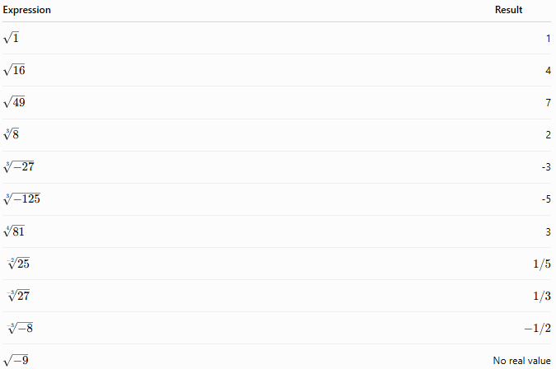
Expression | Result
$$\sqrt{1}$$ | 1
$$\sqrt{16}$$ | 4
$$\sqrt{49}$$ | 7
$$\sqrt[3]{8}$$ | 2
$$\sqrt[3]{-27}$$ | -3
$$\sqrt[3]{-125}$$ | -5
$$\sqrt[4]{81}$$ | 3
$$\sqrt[-2]{25}$$ | $$1/5$$
$$\sqrt[-3]{27}$$ | $$1/3$$
$$\sqrt[-3]{-8}$$ | $$-1/2$$
$$\sqrt{-9}$$ | No real value

Properties of Signed Number Roots
Let $a$and $b$be signed numbers where the expressions are defined.

1. Root of a Power
# Source: AI Source: Provided by: [Data Path: Persons Table -> ID Column: 1, Name_En Column: Motasem Essam] -> From: [ChatGPT] on [7/11/2026]
$$\sqrt[n]{a^{n}}=a$$
for odd $n$.
For even $n$,
$$\sqrt[n]{a^{n}}=∣a∣$$
Example:
$$\sqrt{{\left(-7\right)}^{2}}=7$$

2. Power of a Root
# Source: AI Source: Provided by: [Data Path: Persons Table -> ID Column: 1, Name_En Column: Motasem Essam] -> From: [ChatGPT] on [7/11/2026]
$$\left(\sqrt[n]{a})^{n} = a\right.$$
Example:
$$\left(\sqrt[3]{-8})^{3}=-8\right.$$

3. Product Rule
# Source: AI Source: Provided by: [Data Path: Persons Table -> ID Column: 1, Name_En Column: Motasem Essam] -> From: [ChatGPT] on [7/11/2026]
$$\sqrt[n]{ab}=\sqrt[n]{a}×\sqrt[n]{b}$$
when both roots are defined.
Example:
$$\sqrt{9×4}=3×2=6$$

4. Quotient Rule
# Source: AI Source: Provided by: [Data Path: Persons Table -> ID Column: 1, Name_En Column: Motasem Essam] -> From: [ChatGPT] on [7/11/2026]
$$\sqrt[n]{\frac{a}{b}}=\frac{\sqrt[n]{a}}{\sqrt[n]{b}}$$
provided $b≠0$and both roots exist.
Example:
$$\sqrt{\frac{36}{4}}=\frac{6}{2}=3$$

5. Odd Root Sign Property
# Source: AI Source: Provided by: [Data Path: Persons Table -> ID Column: 1, Name_En Column: Motasem Essam] -> From: [ChatGPT] on [7/11/2026]
Odd roots preserve the sign.
$$\sqrt[2k+1]{-a}=-\sqrt[2k+1]{a}$$
Example:
$$\sqrt[3]{-216}=-6$$

6. Negative Index Property
# Source: AI Source: Provided by: [Data Path: Persons Table -> ID Column: 1, Name_En Column: Motasem Essam] -> From: [ChatGPT] on [7/11/2026]
A negative root index represents the reciprocal of the corresponding positive-index root.
$$\sqrt[-n]{a}=\frac{1}{\sqrt[n]{a}}=a^{-\frac{1}{n}}$$
Example:
$$\sqrt[-3]{125}=\frac{1}{5}$$

Checking Roots
# Source: AI Source: Provided by: [Data Path: Persons Table -> ID Column: 1, Name_En Column: Motasem Essam] -> From: [ChatGPT] on [7/11/2026]
A root can be verified by exponentiation.
Example:
$$\sqrt[3]{-64}=-4$$
Check:
$$\left(-4)^{3}=-64\right.$$
Example:
$$\sqrt[-3]{64}=\frac{1}{4}$$
Check:
$${\left(\frac{1}{4}\right)}^{-3}=4^{3}=64$$

Real-Life Applications
# Source: AI Source: Provided by: [Data Path: Persons Table -> ID Column: 1, Name_En Column: Motasem Essam] -> From: [ChatGPT] on [7/11/2026]
Roots of signed numbers are used in:
- Algebra
- Geometry
- Physics
- Engineering
- Statistics
- Computer graphics
- Signal processing
- Scientific calculations
- Computer algebra systems

Real-Life Examples
# Source: AI Source: Provided by: [Data Path: Persons Table -> ID Column: 1, Name_En Column: Motasem Essam] -> From: [ChatGPT] on [7/11/2026]
1. Area of a Square
A square has an area of 144 m².
Its side length is:
$$\sqrt{144}=12$$

2. Volume of a Cube
A cube has a volume of −125 cubic units in a mathematical model.
$$\sqrt[3]{-125}=-5$$

3. Physics
Velocity calculations often require taking square roots of energy formulas.

4. Engineering
Engineers use square roots when determining distances, stresses, and electrical quantities.

5. Statistics
Standard deviation is calculated using square roots.

6. Computer Graphics
Distance calculations use square roots in coordinate geometry.

7. Scientific Computing
Negative root indices are sometimes converted into reciprocal powers.
For example,
$$\sqrt[-2]{100}=\frac{1}{10}$$

8. Symbolic Mathematics
Computer algebra systems often rewrite
$$\sqrt[-3]{x}$$
as
$$x^{-\frac{1}{3}}$$
for symbolic simplification.

Common Mistakes
# Source: AI Source: Provided by: [Data Path: Persons Table -> ID Column: 1, Name_En Column: Motasem Essam] -> From: [ChatGPT] on [7/11/2026]
- Assuming every negative number has a real square root.
- Forgetting that the principal square root is always nonnegative.
- Confusing
$$\sqrt{x^{2}}$$
with
$$x$$
since
$$\sqrt{x^{2}}=∣x∣$$
for real numbers.
- Forgetting that odd roots of negative numbers are negative.
- Assuming negative radical indices are standard notation.
- Confusing a negative root index with a negative radicand.

Key Points
# Source: AI Source: Provided by: [Data Path: Persons Table -> ID Column: 1, Name_En Column: Motasem Essam] -> From: [ChatGPT] on [7/11/2026]
- A root is the inverse of exponentiation.
- Positive numbers have real square roots.
- Negative numbers have no real even roots.
- Negative numbers do have real odd roots.
- The principal square root is always nonnegative.
- A negative root index represents the reciprocal of the corresponding positive-index root:
$$\sqrt[-n]{a}=\frac{1}{\sqrt[n]{a}}=a^{-\frac{1}{n}}$$
- Negative radical indices are non-standard notation and are usually rewritten using negative fractional exponents.

Signed Number Exponentiation vs. Root
# Source: AI Source: Provided by: [Data Path: Persons Table -> ID Column: 1, Name_En Column: Motasem Essam] -> From: [ChatGPT] on [7/11/2026]
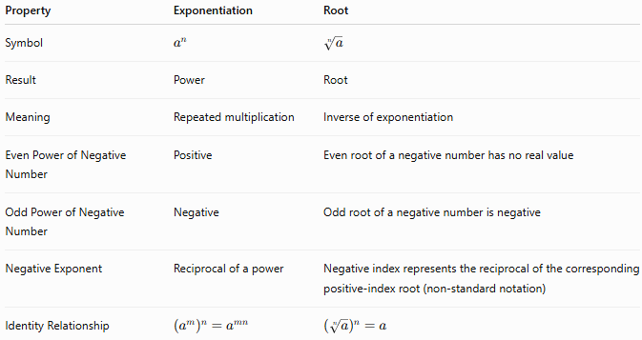
Property | Exponentiation | Root
Symbol | $$a^{n}$$ | $$\sqrt[n]{a}$$
Result | Power | Root
Meaning | Repeated multiplication | Inverse of exponentiation
Even Power of Negative Number | Positive | Even root of a negative number has no real value
Odd Power of Negative Number | Negative | Odd root of a negative number is negative
Negative Exponent | Reciprocal of a power | Negative index represents the reciprocal of the corresponding positive-index root (non-standard notation)
Identity Relationship | $$\left(a^{m})^{n} = a^{mn}\right.$$ | $$\left(\sqrt[n]{a})^{n} = a\right.$$

Conclusion
# Source: AI Source: Provided by: [Data Path: Persons Table -> ID Column: 1, Name_En Column: Motasem Essam] -> From: [ChatGPT] on [7/11/2026]
Root (radical) is the inverse operation of exponentiation and is used to determine the number that produces a given value when raised to a specified power. For signed numbers, even roots of negative numbers do not exist in the real number system, while odd roots preserve the sign and always exist. Although negative radical indices are not standard mathematical notation, they may be interpreted as the reciprocal of the corresponding positive-index root, equivalent to using a negative fractional exponent. Understanding roots is essential in algebra, geometry, calculus, engineering, physics, statistics, and symbolic computation.

Logarithm
# Source: AI Source: Provided by: [Data Path: Persons Table -> ID Column: 1, Name_En Column: Motasem Essam] -> From: [ChatGPT] on [7/11/2026]
A logarithm is the inverse operation of exponentiation. It answers the question:
"To what exponent must a base be raised to obtain a given number?"
When working with signed numbers, logarithms have important restrictions. In the real number system, logarithms are defined only for positive arguments and positive bases (excluding 1). However, the logarithm value (the exponent) itself may be positive, zero, or negative.
Logarithms are widely used in algebra, science, engineering, finance, computer science, information theory, and many other fields.

Definition
# Source: AI Source: Provided by: [Data Path: Persons Table -> ID Column: 1, Name_En Column: Motasem Essam] -> From: [ChatGPT] on [7/11/2026]
A logarithm is the exponent to which a positive base must be raised to produce a given positive number.
Mathematically,
$${log⁡}_{b}a=x$$
if and only if
$$b^{x}=a$$
where:
- $b$is the base
- $a$is the argument (or logarithmand)
- $x$is the logarithm (the exponent)
The following conditions must hold in the real number system:
Base
$$b>0,b≠1$$
Argument
$$a>0$$
Logarithm
$$x∈R$$
The logarithm value may be:
- Positive
- Zero
- Negative
depending on the values of the base and the argument.

Logarithm Symbols
# Source: AI Source: Provided by: [Data Path: Persons Table -> ID Column: 1, Name_En Column: Motasem Essam] -> From: [ChatGPT] on [7/11/2026]
Common logarithm notation:
$${log⁡}_{b}a$$
Examples:
$${log⁡}_{2}8=3$$
because
$$2^{3}=8$$

Rules for Logarithms of Signed Numbers

1. Positive Argument
# Source: AI Source: Provided by: [Data Path: Persons Table -> ID Column: 1, Name_En Column: Motasem Essam] -> From: [ChatGPT] on [7/11/2026]
A logarithm is defined for every positive argument.
$$a>0$$
The logarithm value may be positive, zero, or negative.

Example 1 (Positive Logarithm)
# Source: AI Source: Provided by: [Data Path: Persons Table -> ID Column: 1, Name_En Column: Motasem Essam] -> From: [ChatGPT] on [7/11/2026]
$${log⁡}_{2}32=5$$
because
$$2^{5}=32$$
Base:
$$b=2$$
Argument:
$$a=32$$
Logarithm:
$$x=5$$

Example 2 (Zero Logarithm)
# Source: AI Source: Provided by: [Data Path: Persons Table -> ID Column: 1, Name_En Column: Motasem Essam] -> From: [ChatGPT] on [7/11/2026]
$${log⁡}_{7}1=0$$
because
$$7^{0}=1$$
Base:
$$b=7$$
Argument:
$$a=1$$
Logarithm:
$$x=0$$

Example 3 (Negative Logarithm)
# Source: AI Source: Provided by: [Data Path: Persons Table -> ID Column: 1, Name_En Column: Motasem Essam] -> From: [ChatGPT] on [7/11/2026]
$${log⁡}_{2}\left(\frac{1}{8}\right)=-3$$
because
$$2^{-3}=\frac{1}{8}$$
Base:
$$b=2$$
Argument:
$$a=\frac{1}{8}$$
Logarithm:
$$x=-3$$

2. Logarithm of One
# Source: AI Source: Provided by: [Data Path: Persons Table -> ID Column: 1, Name_En Column: Motasem Essam] -> From: [ChatGPT] on [7/11/2026]
The logarithm of 1 is always zero.
$${log⁡}_{b}1=0$$
because
$$b^{0}=1$$
Example
$${log⁡}_{5}1=0$$
Base:
$$b=5$$
Argument:
$$a=1$$
Logarithm:
$$x=0$$

3. Logarithm of Zero
# Source: AI Source: Provided by: [Data Path: Persons Table -> ID Column: 1, Name_En Column: Motasem Essam] -> From: [ChatGPT] on [7/11/2026]
The logarithm of zero is undefined.
$${log⁡}_{b}0$$
There is no real exponent $x$such that
$$b^{x}=0$$
Example
$${log⁡}_{2}0$$
Base:
$$b=2$$
Argument:
$$a=0$$
Logarithm:
Undefined

4. Logarithm of a Negative Argument
# Source: AI Source: Provided by: [Data Path: Persons Table -> ID Column: 1, Name_En Column: Motasem Essam] -> From: [ChatGPT] on [7/11/2026]
A logarithm of a negative number is not defined in the real numbers.
Example
$${log⁡}_{2}(-8)$$
Base:
$$b=2$$
Argument:
$$a=-8$$
Logarithm:
Undefined

5. Negative Base
# Source: AI Source: Provided by: [Data Path: Persons Table -> ID Column: 1, Name_En Column: Motasem Essam] -> From: [ChatGPT] on [7/11/2026]
A logarithm with a negative base is not defined in the real number system.
Example
$${log⁡}_{-2}8$$
Base:
$$b=-2$$
Argument:
$$a=8$$
Logarithm:
Undefined

6. Base Equal to One
# Source: AI Source: Provided by: [Data Path: Persons Table -> ID Column: 1, Name_En Column: Motasem Essam] -> From: [ChatGPT] on [7/11/2026]
The base of a logarithm cannot be 1.
Example
$${log⁡}_{1}8$$
Base:
$$b=1$$
Argument:
$$a=8$$
Logarithm:
Undefined

7. Fractional Positive Argument
# Source: AI Source: Provided by: [Data Path: Persons Table -> ID Column: 1, Name_En Column: Motasem Essam] -> From: [ChatGPT] on [7/11/2026]
If
$$0<a<1$$
and
$$b>1,$$
then the logarithm is negative.
Example
$${log⁡}_{10}(0.01)=-2$$
because
$${10}^{-2}=0.01$$
Base:
$$b=10$$
Argument:
$$a=0.01$$
Logarithm:
$$x=-2$$

Relationship Between Logarithms and Powers
# Source: AI Source: Provided by: [Data Path: Persons Table -> ID Column: 1, Name_En Column: Motasem Essam] -> From: [ChatGPT] on [7/11/2026]
Logarithms and exponentiation are inverse operations.
$${log⁡}_{b}(b^{x})=x$$
and
$$b^{{log⁡}_{b}a}=a$$
Example:
$${log⁡}_{3}(3^{5})=5$$
and
$$3^{{log⁡}_{3}27}=27$$

Examples
# Source: AI Source: Provided by: [Data Path: Persons Table -> ID Column: 1, Name_En Column: Motasem Essam] -> From: [ChatGPT] on [7/11/2026]
Example 1
$${log⁡}_{2}64=6$$

Example 2
$${log⁡}_{5}125=3$$

Example 3
$${log⁡}_{10}0.001=-3$$

Example 4
$${log⁡}_{7}1=0$$

Example 5
$${log⁡}_{2}(-16)$$
No real value.

Example 6
$${log⁡}_{4}\left(\frac{1}{64}\right)=-3$$

Common Logarithms Table
# Source: AI Source: Provided by: [Data Path: Persons Table -> ID Column: 1, Name_En Column: Motasem Essam] -> From: [ChatGPT] on [7/11/2026]
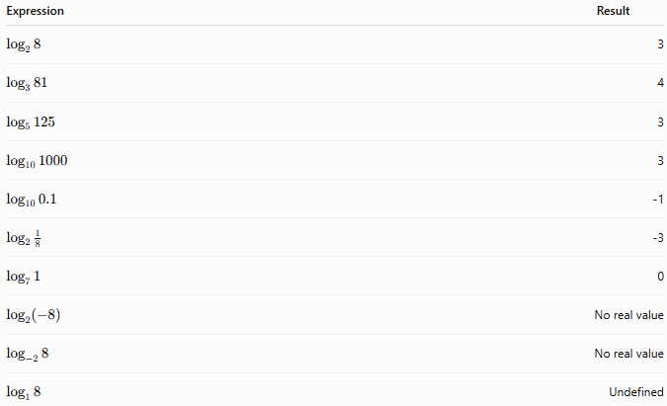
Expression | Result
$${log⁡}_{2}8$$ | 3
$${log⁡}_{3}81$$ | 4
$${log⁡}_{5}125$$ | 3
$${log⁡}_{10}1000$$ | 3
$${log⁡}_{10}0.1$$ | -1
$${log⁡}_{2}\frac{1}{8}$$ | -3
$${log⁡}_{7}1$$ | 0
$${log⁡}_{2}(-8)$$ | No real value
$${log⁡}_{-2}8$$ | No real value
$${log⁡}_{1}8$$ | Undefined

Properties of Signed Number Logarithms
Let $a$, $b$, and $c$be positive real numbers, where
$$b≠1$$

1. Product Rule
# Source: AI Source: Provided by: [Data Path: Persons Table -> ID Column: 1, Name_En Column: Motasem Essam] -> From: [ChatGPT] on [7/11/2026]
$${log⁡}_{b}(ac)={log⁡}_{b}a+{log⁡}_{b}c$$
Example:
$${log⁡}_{2}(8×4)=3+2=5$$

2. Quotient Rule
# Source: AI Source: Provided by: [Data Path: Persons Table -> ID Column: 1, Name_En Column: Motasem Essam] -> From: [ChatGPT] on [7/11/2026]
$${log⁡}_{b}\left(\frac{a}{c}\right)={log⁡}_{b}a-{log⁡}_{b}c$$
Example:
$${log⁡}_{2}\left(\frac{32}{4}\right)=5-2=3$$

3. Power Rule
# Source: AI Source: Provided by: [Data Path: Persons Table -> ID Column: 1, Name_En Column: Motasem Essam] -> From: [ChatGPT] on [7/11/2026]
$${log⁡}_{b}(a^{n})=n{log⁡}_{b}a$$
Example:
$${log⁡}_{2}(8^{2})=2×3=6$$

4. Change of Base Formula
# Source: AI Source: Provided by: [Data Path: Persons Table -> ID Column: 1, Name_En Column: Motasem Essam] -> From: [ChatGPT] on [7/11/2026]
$${log⁡}_{b}a=\frac{{log⁡}_{c}a}{{log⁡}_{c}b}$$
Example:
$${log⁡}_{2}8=\frac{\log{108}}{\log{102}}=3$$

5. Inverse Property
# Source: AI Source: Provided by: [Data Path: Persons Table -> ID Column: 1, Name_En Column: Motasem Essam] -> From: [ChatGPT] on [7/11/2026]
$${log⁡}_{b}(b^{x})=x$$
Example:
$${log⁡}_{5}(5^{4})=4$$

6. Exponential Property
# Source: AI Source: Provided by: [Data Path: Persons Table -> ID Column: 1, Name_En Column: Motasem Essam] -> From: [ChatGPT] on [7/11/2026]
$$b^{{log⁡}_{b}a}=a$$
Example:
$$3^{{log⁡}_{3}81}=81$$

Checking Logarithms
# Source: AI Source: Provided by: [Data Path: Persons Table -> ID Column: 1, Name_En Column: Motasem Essam] -> From: [ChatGPT] on [7/11/2026]
A logarithm can be verified using exponentiation.
Example:
$${log⁡}_{2}32=5$$
Check:
$$2^{5}=32$$
Since the original argument is obtained, the logarithm is correct.

Real-Life Applications
# Source: AI Source: Provided by: [Data Path: Persons Table -> ID Column: 1, Name_En Column: Motasem Essam] -> From: [ChatGPT] on [7/11/2026]
Logarithms are used in:
- Algebra
- Engineering
- Physics
- Chemistry (pH scale)
- Earthquake measurement (Richter scale)
- Finance (compound interest)
- Computer science
- Information theory
- Machine learning
- Data analysis

Real-Life Examples
# Source: AI Source: Provided by: [Data Path: Persons Table -> ID Column: 1, Name_En Column: Motasem Essam] -> From: [ChatGPT] on [7/11/2026]
1. Earthquake Magnitude
The Richter scale is logarithmic. Each increase of 1 represents a tenfold increase in seismic wave amplitude.

2. Sound Intensity
The decibel (dB) scale uses logarithms to measure sound levels.

3. Acidity
The pH scale is based on logarithms.

4. Finance
Compound interest calculations involve logarithms when solving for time or interest rates.

5. Population Growth
Scientists use logarithms to estimate growth over time.

6. Computer Science
Algorithms such as binary search have logarithmic time complexity.
$$O(log⁡n)$$

7. Information Theory
Logarithms measure information content and data compression.

8. Machine Learning
Cross-entropy and many optimization algorithms use logarithmic functions.

Common Mistakes
# Source: AI Source: Provided by: [Data Path: Persons Table -> ID Column: 1, Name_En Column: Motasem Essam] -> From: [ChatGPT] on [7/11/2026]
- Attempting to compute the logarithm of a negative number.
- Attempting to compute the logarithm of zero.
- Using a negative base.
- Using a base equal to 1.
- Forgetting that only the logarithm value may be negative.
- Confusing logarithms with exponents.

Key Points
# Source: AI Source: Provided by: [Data Path: Persons Table -> ID Column: 1, Name_En Column: Motasem Essam] -> From: [ChatGPT] on [7/11/2026]
- A logarithm is the inverse of exponentiation.
- The base must satisfy
$$b>0,b≠1$$
- The argument must satisfy
$$a>0$$
- The logarithm value may be positive, zero, or negative.
- The logarithm of 1 is 0.
- The logarithm of 0 is undefined.
- Negative arguments have no real logarithms.
- Negative bases are not allowed in the real number system.

Summary of Possible Signs
# Source: AI Source: Provided by: [Data Path: Persons Table -> ID Column: 1, Name_En Column: Motasem Essam] -> From: [ChatGPT] on [7/11/2026]
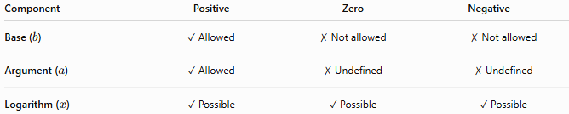
Component | Positive | Zero | Negative
Base ($b$) | ✓ Allowed | ✗ Not allowed | ✗ Not allowed
Argument ($a$) | ✓ Allowed | ✗ Undefined | ✗ Undefined
Logarithm ($x$) | ✓ Possible | ✓ Possible | ✓ Possible

Signed Number Exponentiation vs. Logarithm
# Source: AI Source: Provided by: [Data Path: Persons Table -> ID Column: 1, Name_En Column: Motasem Essam] -> From: [ChatGPT] on [7/11/2026]
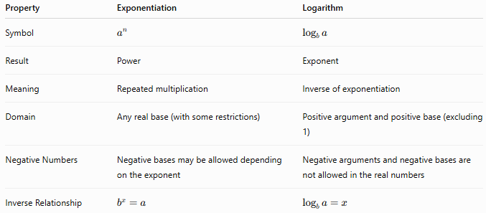
Property | Exponentiation | Logarithm
Symbol | $$a^{n}$$ | $${log⁡}_{b}a$$
Result | Power | Exponent
Meaning | Repeated multiplication | Inverse of exponentiation
Domain | Any real base (with some restrictions) | Positive argument and positive base (excluding 1)
Negative Numbers | Negative bases may be allowed depending on the exponent | Negative arguments and negative bases are not allowed in the real numbers
Inverse Relationship | $$b^{x}=a$$ | $${log⁡}_{b}a=x$$

Conclusion
# Source: AI Source: Provided by: [Data Path: Persons Table -> ID Column: 1, Name_En Column: Motasem Essam] -> From: [ChatGPT] on [7/11/2026]
A logarithm is the inverse of exponentiation and determines the exponent required to produce a given positive number from a specified positive base. In the real number system, the base must be positive and not equal to 1, and the argument must be positive. While the base and argument cannot be negative, the logarithm value itself may be positive, zero, or negative, making logarithms an important arithmetic operation involving signed numbers. They are fundamental in mathematics and have extensive applications in science, engineering, finance, computer science, and information theory.

Natural Logarithm
# Source: AI Source: Provided by: [Data Path: Persons Table -> ID Column: 1, Name_En Column: Motasem Essam] -> From: [ChatGPT] on [7/11/2026]
The natural logarithm is a special type of logarithm whose base is the mathematical constant $e$, where
$$e≈2.718281828$$
It answers the question:
"To what power must $e$be raised to obtain a given positive number?"
Like all logarithms, the natural logarithm is defined only for positive arguments in the real number system. Although the argument must be positive, the natural logarithm value may be positive, zero, or negative.
Natural logarithms are widely used in calculus, differential equations, physics, engineering, probability, finance, biology, and computer science.

Definition
# Source: AI Source: Provided by: [Data Path: Persons Table -> ID Column: 1, Name_En Column: Motasem Essam] -> From: [ChatGPT] on [7/11/2026]
The natural logarithm is the logarithm with base $e$.
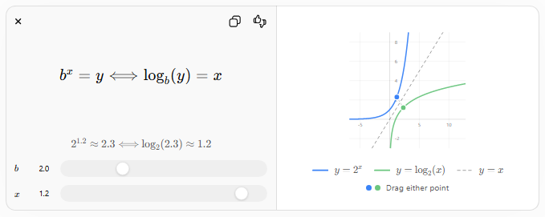
$$b^{x}=y⟺{log⁡}_{b}(y)=x$$
$$2^{1.2}≈2.3⟺{log⁡}_{2} \text{⁣}\left(2.3\right)≈1.2$$
$$b$$
$$b$$
$$x$$
$$x$$
-5510-22468
$$y=2^{x}$$
$$y={log⁡}_{2}(x)$$
$$y=x$$
Drag either point
Mathematically,
$$ln⁡a=x$$
is equivalent to
$$e^{x}=a$$
where:
- $e$is the base (Euler's number)
$$e≈2.718281828$$
- $a$is the argument (or logarithmand)
- $x$is the natural logarithm (the exponent)
The following conditions must hold in the real number system.
Base
The base is always
$$e>0$$
and
$$e≠1$$

Argument
# Source: AI Source: Provided by: [Data Path: Persons Table -> ID Column: 1, Name_En Column: Motasem Essam] -> From: [ChatGPT] on [7/11/2026]
$$a>0$$

Natural Logarithm
# Source: AI Source: Provided by: [Data Path: Persons Table -> ID Column: 1, Name_En Column: Motasem Essam] -> From: [ChatGPT] on [7/11/2026]
$$x∈R$$
The natural logarithm value may be:
- Positive
- Zero
- Negative
depending on the value of the argument.

Natural Logarithm Symbols
# Source: AI Source: Provided by: [Data Path: Persons Table -> ID Column: 1, Name_En Column: Motasem Essam] -> From: [ChatGPT] on [7/11/2026]
The natural logarithm is written as
$$\ln{a}$$
or equivalently
$${log⁡}_{e}a$$
Example:
$$ln⁡(e^{3})=3$$
because
$$e^{3}=e^{3}$$

Rules for Natural Logarithms of Signed Numbers

1. Positive Argument
# Source: AI Source: Provided by: [Data Path: Persons Table -> ID Column: 1, Name_En Column: Motasem Essam] -> From: [ChatGPT] on [7/11/2026]
The natural logarithm is defined for every positive argument.
$$a>0$$
The logarithm value may be positive, zero, or negative.

Example 1 (Positive Logarithm)
# Source: AI Source: Provided by: [Data Path: Persons Table -> ID Column: 1, Name_En Column: Motasem Essam] -> From: [ChatGPT] on [7/11/2026]
$$ln⁡(e^{5})=5$$
Base:
$$e$$
Argument:
$$e^{5}$$
Natural logarithm:
$$5$$

Example 2 (Zero Logarithm)
# Source: AI Source: Provided by: [Data Path: Persons Table -> ID Column: 1, Name_En Column: Motasem Essam] -> From: [ChatGPT] on [7/11/2026]
$$ln⁡1=0$$
because
$$e^{0}=1$$
Base:
$$e$$
Argument:
$$1$$
Natural logarithm:
$$0$$

Example 3 (Negative Logarithm)
# Source: AI Source: Provided by: [Data Path: Persons Table -> ID Column: 1, Name_En Column: Motasem Essam] -> From: [ChatGPT] on [7/11/2026]
$$ln⁡\left(\frac{1}{e}\right)=-1$$
because
$$e^{-1}=\frac{1}{e}$$
Base:
$$e$$
Argument:
$$\frac{1}{e}$$
Natural logarithm:
$$-1$$

2. Natural Logarithm of One
# Source: AI Source: Provided by: [Data Path: Persons Table -> ID Column: 1, Name_En Column: Motasem Essam] -> From: [ChatGPT] on [7/11/2026]
The natural logarithm of 1 is always zero.
$$ln⁡1=0$$
because
$$e^{0}=1$$
Example
$$ln⁡1=0$$
Base:
$$e$$
Argument:
$$1$$
Natural logarithm:
$$0$$

3. Natural Logarithm of Zero
# Source: AI Source: Provided by: [Data Path: Persons Table -> ID Column: 1, Name_En Column: Motasem Essam] -> From: [ChatGPT] on [7/11/2026]
The natural logarithm of zero is undefined.
$$\ln{0}$$
There is no real exponent $x$such that
$$e^{x}=0$$
Example
$$\ln{0}$$
Base:
$$e$$
Argument:
$$0$$
Natural logarithm:
Undefined

4. Natural Logarithm of a Negative Number
# Source: AI Source: Provided by: [Data Path: Persons Table -> ID Column: 1, Name_En Column: Motasem Essam] -> From: [ChatGPT] on [7/11/2026]
The natural logarithm of a negative number is not defined in the real numbers.
Example
$$ln⁡(-8)$$
Base:
$$e$$
Argument:
$$-8$$
Natural logarithm:
Undefined

5. Positive Fractional Argument
# Source: AI Source: Provided by: [Data Path: Persons Table -> ID Column: 1, Name_En Column: Motasem Essam] -> From: [ChatGPT] on [7/11/2026]
If
$$0<a<1$$
then
$$ln⁡(a)<0$$
Example
$$ln⁡\left(\frac{1}{e^{2}}\right)=-2$$
because
$$e^{-2}=\frac{1}{e^{2}}$$
Base:
$$e$$
Argument:
$$\frac{1}{e^{2}}$$
Natural logarithm:
$$-2$$

Relationship Between Natural Logarithms and Powers
# Source: AI Source: Provided by: [Data Path: Persons Table -> ID Column: 1, Name_En Column: Motasem Essam] -> From: [ChatGPT] on [7/11/2026]
Natural logarithms and exponential functions are inverse operations.
$$ln⁡(e^{x})=x$$
and
$$e^{\ln{a}}=a$$
Example:
$$ln⁡(e^{7})=7$$
and
$$e^{\ln{25}}=25$$

Examples
# Source: AI Source: Provided by: [Data Path: Persons Table -> ID Column: 1, Name_En Column: Motasem Essam] -> From: [ChatGPT] on [7/11/2026]
Example 1
$$ln⁡(e^{4})=4$$

Example 2
$$ln⁡(e)=1$$

Example 3
$$ln⁡1=0$$

Example 4
$$ln⁡\left(\frac{1}{e}\right)=-1$$

Example 5
$$ln⁡(-5)$$
No real value.

Example 6
$$\ln{0}$$
Undefined.

Common Natural Logarithms Table
# Source: AI Source: Provided by: [Data Path: Persons Table -> ID Column: 1, Name_En Column: Motasem Essam] -> From: [ChatGPT] on [7/11/2026]
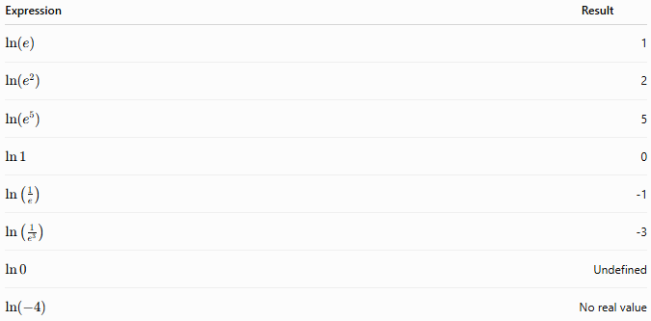
Expression | Result
$$ln⁡(e)$$ | 1
$$ln⁡(e^{2})$$ | 2
$$ln⁡(e^{5})$$ | 5
$$\ln{1}$$ | 0
$$\ln\left(\frac{1}{e}\right)$$ | -1
$$\ln\left(\frac{1}{e^{3}}\right)$$ | -3
$$\ln{0}$$ | Undefined
$$ln⁡(-4)$$ | No real value

Properties of Signed Number Natural Logarithms
# Source: AI Source: Provided by: [Data Path: Persons Table -> ID Column: 1, Name_En Column: Motasem Essam] -> From: [ChatGPT] on [7/11/2026]
Let $a$and $b$be positive real numbers.

1. Product Rule
# Source: AI Source: Provided by: [Data Path: Persons Table -> ID Column: 1, Name_En Column: Motasem Essam] -> From: [ChatGPT] on [7/11/2026]
$$ln⁡(ab)=ln⁡a+ln⁡b$$
Example:
$$ln⁡(e^{2}×e^{3})=2+3=5$$

2. Quotient Rule
# Source: AI Source: Provided by: [Data Path: Persons Table -> ID Column: 1, Name_En Column: Motasem Essam] -> From: [ChatGPT] on [7/11/2026]
$$ln⁡\left(\frac{a}{b}\right)=ln⁡a-ln⁡b$$
Example:
$$ln⁡\left(\frac{e^{5}}{e^{2}}\right)=5-2=3$$

3. Power Rule
# Source: AI Source: Provided by: [Data Path: Persons Table -> ID Column: 1, Name_En Column: Motasem Essam] -> From: [ChatGPT] on [7/11/2026]
$$ln⁡(a^{n})=nln⁡a$$
Example:
$$ln⁡(e^{6})=6$$

4. Exponential Inverse Property
# Source: AI Source: Provided by: [Data Path: Persons Table -> ID Column: 1, Name_En Column: Motasem Essam] -> From: [ChatGPT] on [7/11/2026]
$$ln⁡(e^{x})=x$$
Example:
$$ln⁡(e^{-4})=-4$$

5. Logarithmic Inverse Property
# Source: AI Source: Provided by: [Data Path: Persons Table -> ID Column: 1, Name_En Column: Motasem Essam] -> From: [ChatGPT] on [7/11/2026]
$$e^{\ln{a}}=a$$
Example:
$$e^{\ln{12}}=12$$

6. Change of Base Formula
# Source: AI Source: Provided by: [Data Path: Persons Table -> ID Column: 1, Name_En Column: Motasem Essam] -> From: [ChatGPT] on [7/11/2026]
$${log⁡}_{b}a=\frac{\ln{a}}{\ln{b}}$$
Example:
$${log⁡}_{2}8=\frac{\ln{8}}{\ln{2}}=3$$

Checking Natural Logarithms
# Source: AI Source: Provided by: [Data Path: Persons Table -> ID Column: 1, Name_En Column: Motasem Essam] -> From: [ChatGPT] on [7/11/2026]
A natural logarithm can be verified using exponentiation.
Example:
$$ln⁡(e^{4})=4$$
Check:
$$e^{4}=e^{4}$$
Since the original argument is obtained, the natural logarithm is correct.

Real-Life Applications
# Source: AI Source: Provided by: [Data Path: Persons Table -> ID Column: 1, Name_En Column: Motasem Essam] -> From: [ChatGPT] on [7/11/2026]
Natural logarithms are used in:
- Calculus
- Differential equations
- Physics
- Engineering
- Finance
- Probability
- Statistics
- Biology
- Chemistry
- Computer science

Real-Life Examples
# Source: AI Source: Provided by: [Data Path: Persons Table -> ID Column: 1, Name_En Column: Motasem Essam] -> From: [ChatGPT] on [7/11/2026]
1. Compound Interest
Continuous compound interest uses the natural logarithm when solving for time.

2. Population Growth
Natural logarithms are used in exponential growth and decay models.

3. Radioactive Decay
Scientists use natural logarithms to determine the age of radioactive materials.

4. Physics
Natural logarithms appear in equations involving heat transfer and electricity.

5. Chemistry
Reaction-rate equations often involve natural logarithms.

6. Biology
Population models and enzyme kinetics use natural logarithms.

7. Statistics
Many probability distributions use natural logarithms.

8. Machine Learning
Natural logarithms are widely used in likelihood functions and cross-entropy loss.

Common Mistakes
# Source: AI Source: Provided by: [Data Path: Persons Table -> ID Column: 1, Name_En Column: Motasem Essam] -> From: [ChatGPT] on [7/11/2026]
- Trying to compute $ln⁡$of a negative number.
- Trying to compute $\ln{0}$.
- Forgetting that the base of the natural logarithm is always $e$.
- Confusing $ln⁡$with common logarithm (${log⁡}_{10}$).
- Forgetting that only the logarithm value may be negative.

Key Points
# Source: AI Source: Provided by: [Data Path: Persons Table -> ID Column: 1, Name_En Column: Motasem Essam] -> From: [ChatGPT] on [7/11/2026]
- The natural logarithm has base $e$.
- The argument must satisfy
$$a>0$$
- The natural logarithm value may be positive, zero, or negative.
- $ln⁡1=0$.
- $\ln{0}$is undefined.
- Negative numbers have no real natural logarithm.
- The natural logarithm and the exponential function are inverse operations.

Summary of Possible Signs
# Source: AI Source: Provided by: [Data Path: Persons Table -> ID Column: 1, Name_En Column: Motasem Essam] -> From: [ChatGPT] on [7/11/2026]
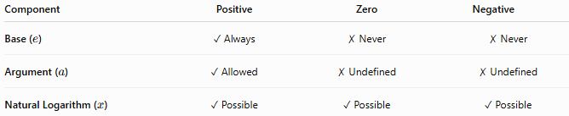
Component | Positive | Zero | Negative
Base ($e$) | ✓ Always | ✗ Never | ✗ Never
Argument ($a$) | ✓ Allowed | ✗ Undefined | ✗ Undefined
Natural Logarithm ($x$) | ✓ Possible | ✓ Possible | ✓ Possible

Common Logarithm vs. Natural Logarithm
# Source: AI Source: Provided by: [Data Path: Persons Table -> ID Column: 1, Name_En Column: Motasem Essam] -> From: [ChatGPT] on [7/11/2026]
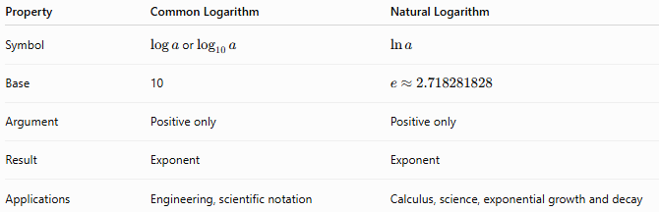
Property | Common Logarithm | Natural Logarithm
Symbol | $\log{a}$or ${log⁡}_{10}a$ | $$\ln{a}$$
Base | 10 | $$e≈2.718281828$$
Argument | Positive only | Positive only
Result | Exponent | Exponent
Applications | Engineering, scientific notation | Calculus, science, exponential growth and decay

Conclusion
# Source: AI Source: Provided by: [Data Path: Persons Table -> ID Column: 1, Name_En Column: Motasem Essam] -> From: [ChatGPT] on [7/11/2026]
The natural logarithm is the logarithm with base $e$, making it the inverse of the exponential function $e^{x}$. In the real number system, it is defined only for positive arguments, while its value may be positive, zero, or negative depending on the argument. The natural logarithm is one of the most important functions in mathematics and is widely used in calculus, science, engineering, finance, probability, statistics, and computer science.

Absolute Value
# Source: AI Source: Provided by: [Data Path: Persons Table -> ID Column: 1, Name_En Column: Motasem Essam] -> From: [ChatGPT] on [7/11/2026]
The absolute value of a signed number is its distance from zero on the number line, regardless of its direction (sign). Because distance is never negative, the absolute value of any real number is always zero or positive.
Absolute value is widely used in arithmetic, algebra, geometry, calculus, physics, engineering, computer science, and statistics.

Definition
# Source: AI Source: Provided by: [Data Path: Persons Table -> ID Column: 1, Name_En Column: Motasem Essam] -> From: [ChatGPT] on [7/11/2026]
The absolute value of a signed number is its non-negative distance from zero on the number line.
$$∣x∣$$
$$∣-3∣=3$$
|x| = −x
Distance from 0
−6−5−4−3−2−10123456
Drag the point left or right
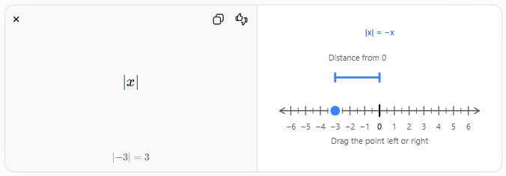
Mathematically,
$$∣x∣=\left\{\begin{matrix}x, & x≥0 \\ -x, & x<0\end{matrix}\right.$$
where:
- $x$is the signed number
- $∣x∣$is the absolute value (distance from zero)
The absolute value is always
$$∣x∣≥0$$

Absolute Value Symbol
# Source: AI Source: Provided by: [Data Path: Persons Table -> ID Column: 1, Name_En Column: Motasem Essam] -> From: [ChatGPT] on [7/11/2026]
The absolute value of a number is written using vertical bars.
Examples:
$$∣8∣=8 \\ ∣-8∣=8 \\ ∣0∣=0$$

Rules for Absolute Values of Signed Numbers

1. Positive Number
# Source: AI Source: Provided by: [Data Path: Persons Table -> ID Column: 1, Name_En Column: Motasem Essam] -> From: [ChatGPT] on [7/11/2026]
The absolute value of a positive number is the number itself.
$$∣a∣=a$$
where
$$a>0$$
Example
$$∣12∣=12$$
Signed Number:
$$12$$
Absolute Value:
$$12$$

2. Negative Number
# Source: AI Source: Provided by: [Data Path: Persons Table -> ID Column: 1, Name_En Column: Motasem Essam] -> From: [ChatGPT] on [7/11/2026]
The absolute value of a negative number is its positive counterpart.
$$∣-a∣=a$$
where
$$a>0$$
Example
$$∣-12∣=12$$
Signed Number:
$$-12$$
Absolute Value:
$$12$$

3. Zero
# Source: AI Source: Provided by: [Data Path: Persons Table -> ID Column: 1, Name_En Column: Motasem Essam] -> From: [ChatGPT] on [7/11/2026]
The absolute value of zero is zero.
$$∣0∣=0$$
Example
$$∣0∣=0$$
Signed Number:
$$0$$
Absolute Value:
$$0$$

4. Opposite Numbers
# Source: AI Source: Provided by: [Data Path: Persons Table -> ID Column: 1, Name_En Column: Motasem Essam] -> From: [ChatGPT] on [7/11/2026]
Opposite numbers have the same absolute value.
$$∣a∣=∣-a∣$$
Example
$$∣9∣=∣-9∣=9$$

5. Absolute Value Is Never Negative
# Source: AI Source: Provided by: [Data Path: Persons Table -> ID Column: 1, Name_En Column: Motasem Essam] -> From: [ChatGPT] on [7/11/2026]
For every real number,
$$∣x∣≥0$$
Example
$$∣-25∣=25$$
The result is never
$$-25$$

6. Absolute Value of an Absolute Value
# Source: AI Source: Provided by: [Data Path: Persons Table -> ID Column: 1, Name_En Column: Motasem Essam] -> From: [ChatGPT] on [7/11/2026]
Taking the absolute value more than once does not change the result.
$$∣∣x∣∣=∣x∣$$
Example
$$∣∣-18∣∣=18$$

Relationship Between Signed Numbers and Absolute Values
# Source: AI Source: Provided by: [Data Path: Persons Table -> ID Column: 1, Name_En Column: Motasem Essam] -> From: [ChatGPT] on [7/11/2026]
The absolute value removes the sign but preserves the magnitude.
Examples:
$$∣-15∣=15 \\ ∣15∣=15 \\ ∣0∣=0$$

Examples
# Source: AI Source: Provided by: [Data Path: Persons Table -> ID Column: 1, Name_En Column: Motasem Essam] -> From: [ChatGPT] on [7/11/2026]
Example 1
$$∣35∣=35$$

Example 2
$$∣-35∣=35$$

Example 3
$$∣0∣=0$$

Example 4
$$∣-125∣=125$$

Example 5
$$∣9∣=∣-9∣=9$$

Example 6
$$∣∣-50∣∣=50$$

Properties of Signed Number Absolute Values
# Source: AI Source: Provided by: [Data Path: Persons Table -> ID Column: 1, Name_En Column: Motasem Essam] -> From: [ChatGPT] on [7/11/2026]
Let $a$and $b$be real numbers.

1. Non-Negative Property
# Source: AI Source: Provided by: [Data Path: Persons Table -> ID Column: 1, Name_En Column: Motasem Essam] -> From: [ChatGPT] on [7/11/2026]
$$∣a∣≥0$$
Example:
$$∣-17∣=17$$

2. Symmetry Property
# Source: AI Source: Provided by: [Data Path: Persons Table -> ID Column: 1, Name_En Column: Motasem Essam] -> From: [ChatGPT] on [7/11/2026]
$$∣-a∣=∣a∣$$
Example:
$$∣-11∣=∣11∣=11$$

3. Product Property
# Source: AI Source: Provided by: [Data Path: Persons Table -> ID Column: 1, Name_En Column: Motasem Essam] -> From: [ChatGPT] on [7/11/2026]
$$∣ab∣=∣a∣∣b∣$$
Example:
$$∣(-4)(5)∣=∣-20∣=20=4×5$$

4. Quotient Property
# Source: AI Source: Provided by: [Data Path: Persons Table -> ID Column: 1, Name_En Column: Motasem Essam] -> From: [ChatGPT] on [7/11/2026]
For
$$b≠0 \\ ∣\frac{a}{b}∣=\frac{∣a∣}{∣b∣}$$
Example:
$$∣\frac{-18}{6}∣=\frac{18}{6}=3$$

5. Power Property
# Source: AI Source: Provided by: [Data Path: Persons Table -> ID Column: 1, Name_En Column: Motasem Essam] -> From: [ChatGPT] on [7/11/2026]
$$∣a^{n}∣=∣a∣^{n}$$
Example:
$$∣(-3)^{4}∣=∣81∣=81$$

6. Triangle Inequality
# Source: AI Source: Provided by: [Data Path: Persons Table -> ID Column: 1, Name_En Column: Motasem Essam] -> From: [ChatGPT] on [7/11/2026]
$$∣a+b∣≤∣a∣+∣b∣$$
Example:
$$∣-4+7∣=3≤4+7=11$$

Checking Absolute Values
# Source: AI Source: Provided by: [Data Path: Persons Table -> ID Column: 1, Name_En Column: Motasem Essam] -> From: [ChatGPT] on [7/11/2026]
An absolute value can be verified by measuring the distance from zero.
Example:
$$∣-9∣=9$$
Check:
The distance between
$$-9$$
and
$$0$$
is
$$9$$
units.

Real-Life Applications
# Source: AI Source: Provided by: [Data Path: Persons Table -> ID Column: 1, Name_En Column: Motasem Essam] -> From: [ChatGPT] on [7/11/2026]
Absolute values are used in:
- Arithmetic
- Algebra
- Geometry
- Calculus
- Physics
- Engineering
- Computer science
- Statistics
- Economics
- Data analysis

Real-Life Examples
# Source: AI Source: Provided by: [Data Path: Persons Table -> ID Column: 1, Name_En Column: Motasem Essam] -> From: [ChatGPT] on [7/11/2026]
1. Distance
A person is located at
$$-8$$
meters relative to a reference point.
Distance from the reference point:
$$∣-8∣=8$$
meters.

2. Temperature Difference
A temperature of
$$-{12}^{∘}C$$
is
$${12}^{∘}C$$
away from zero.

3. Elevation
A submarine is
$$-250$$
meters below sea level.
Its depth is
$$250$$
meters.

4. Finance
A loss of
$$-500$$
dollars has an absolute value of
$$500$$
dollars.

5. Physics
Displacement may be negative, but distance traveled is always non-negative.

6. Error Measurement
Absolute error is calculated using absolute values.

7. Statistics
Mean absolute deviation measures average distance from the mean.

8. Computer Science
Absolute values are used in graphics, optimization algorithms, and distance calculations.

Common Mistakes
# Source: AI Source: Provided by: [Data Path: Persons Table -> ID Column: 1, Name_En Column: Motasem Essam] -> From: [ChatGPT] on [7/11/2026]
- Thinking that the absolute value of a negative number remains negative.
- Confusing absolute value with parentheses.
- Assuming
$$∣a+b∣=∣a∣+∣b∣$$
always holds.
- Forgetting that absolute value represents distance.
- Assuming absolute values can be negative.

Key Points
# Source: AI Source: Provided by: [Data Path: Persons Table -> ID Column: 1, Name_En Column: Motasem Essam] -> From: [ChatGPT] on [7/11/2026]
- Absolute value measures the distance from zero.
- Absolute values are always non-negative.
- Opposite numbers have the same absolute value.
- The sign of a number is removed by the absolute value operation.
- Distance is always measured as a non-negative quantity.

Signed Number vs. Absolute Value
# Source: AI Source: Provided by: [Data Path: Persons Table -> ID Column: 1, Name_En Column: Motasem Essam] -> From: [ChatGPT] on [7/11/2026]
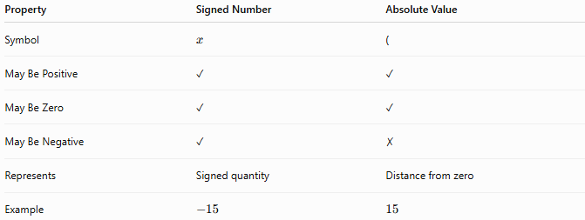
Property | Signed Number | Absolute Value
Symbol | $$x$$ | (
May Be Positive | ✓ | ✓
May Be Zero | ✓ | ✓
May Be Negative | ✓ | ✗
Represents | Signed quantity | Distance from zero
Example | $$-15$$ | $$15$$

Conclusion
# Source: AI Source: Provided by: [Data Path: Persons Table -> ID Column: 1, Name_En Column: Motasem Essam] -> From: [ChatGPT] on [7/11/2026]
The absolute value of a signed number is its non-negative distance from zero, regardless of whether the original number is positive, negative, or zero. It removes the sign while preserving the magnitude of the number. Absolute value is a fundamental concept in arithmetic and algebra and has broad applications in geometry, physics, engineering, statistics, computer science, and many other fields where distance or magnitude is important.

Simplifying Radicals
# Source: AI Source: Provided by: [Data Path: Persons Table -> ID Column: 1, Name_En Column: Motasem Essam] -> From: [ChatGPT] on [7/11/2026]
Simplifying Radicals with Signed Numbers is the process of rewriting radical expressions involving positive and negative numbers into their simplest equivalent form while applying the rules for radicals and signed numbers.
The sign of the radicand and the index of the radical determine whether the result is positive, negative, or undefined in the real number system.
Simplifying signed radicals is essential in arithmetic, algebra, geometry, calculus, engineering, and science.

Definition
# Source: AI Source: Provided by: [Data Path: Persons Table -> ID Column: 1, Name_En Column: Motasem Essam] -> From: [ChatGPT] on [7/11/2026]
A signed radical is a radical expression whose radicand is a positive or negative number.
The general form is
$$\sqrt[n]{a}$$
where
- $n$is the index,
- $a$is the signed radicand.
The radical is simplified by extracting perfect powers while applying the sign rules.

Rules for Signed Radicals

Rule 1: Positive Radicand
# Source: AI Source: Provided by: [Data Path: Persons Table -> ID Column: 1, Name_En Column: Motasem Essam] -> From: [ChatGPT] on [7/11/2026]
A positive number has a real root for every positive integer index.
Example
$$\sqrt{36}=6$$

Example
$$\sqrt[3]{125}=5$$

Rule 2: Negative Radicand with an Odd Index
# Source: AI Source: Provided by: [Data Path: Persons Table -> ID Column: 1, Name_En Column: Motasem Essam] -> From: [ChatGPT] on [7/11/2026]
An odd root of a negative number is negative.
$$\sqrt[2k+1]{-a}=-\sqrt[2k+1]{a}$$
Example
$$\sqrt[3]{-27}=-3$$

Example
$$\sqrt[5]{-32}=-2$$

Example
$$\sqrt[3]{-216}=-6$$

Rule 3: Negative Radicand with an Even Index
# Source: AI Source: Provided by: [Data Path: Persons Table -> ID Column: 1, Name_En Column: Motasem Essam] -> From: [ChatGPT] on [7/11/2026]
An even root of a negative number is not defined in the real number system.
Example
$$\sqrt{-25}$$
Undefined in the real numbers.

Example
$$\sqrt[4]{-81}$$
Undefined in the real numbers.

Simplifying Signed Square Roots
# Source: AI Source: Provided by: [Data Path: Persons Table -> ID Column: 1, Name_En Column: Motasem Essam] -> From: [ChatGPT] on [7/11/2026]
Extract perfect squares.
Example
$$\sqrt{72}=6\sqrt{2}$$

Example
$$\sqrt{-72}$$
Undefined in the real numbers.

Simplifying Signed Cube Roots
# Source: AI Source: Provided by: [Data Path: Persons Table -> ID Column: 1, Name_En Column: Motasem Essam] -> From: [ChatGPT] on [7/11/2026]
Extract perfect cubes.
Example
$$\sqrt[3]{-54}=\sqrt[3]{-27×2}=-3\sqrt[3]{2}$$

Example
$$\sqrt[3]{-250}=-5\sqrt[3]{2}$$

Example
$$\sqrt[3]{-432}=-6\sqrt[3]{2}$$

Simplifying Higher-Order Signed Radicals
# Source: AI Source: Provided by: [Data Path: Persons Table -> ID Column: 1, Name_En Column: Motasem Essam] -> From: [ChatGPT] on [7/11/2026]
Example
$$\sqrt[5]{-96}=-2\sqrt[5]{3}$$

Example
$$\sqrt[4]{-48}$$
Undefined in the real numbers.

Product Property
# Source: AI Source: Provided by: [Data Path: Persons Table -> ID Column: 1, Name_En Column: Motasem Essam] -> From: [ChatGPT] on [7/11/2026]
For real numbers,
$$\sqrt[n]{ab}=\sqrt[n]{a}\sqrt[n]{b}$$
provided the radicals are defined.
Example
$$\sqrt[3]{\left(-8)(27\right)}=\sqrt[3]{-216}=-6$$

Example
$$\sqrt{\left(-4)(9\right)}=\sqrt{-36}$$
Undefined in the real numbers.

Quotient Property
# Source: AI Source: Provided by: [Data Path: Persons Table -> ID Column: 1, Name_En Column: Motasem Essam] -> From: [ChatGPT] on [7/11/2026]
$$\sqrt[n]{\frac{a}{b}}=\frac{\sqrt[n]{a}}{\sqrt[n]{b}}$$
provided the radicals are defined and
$$b≠0.$$
Example
$$\sqrt[3]{\frac{-64}{8}}=\sqrt[3]{-8}=-2$$

Example
$$\sqrt{\frac{-36}{9}}=\sqrt{-4}$$
Undefined in the real numbers.

Prime Factorization Method
# Source: AI Source: Provided by: [Data Path: Persons Table -> ID Column: 1, Name_En Column: Motasem Essam] -> From: [ChatGPT] on [7/11/2026]
Prime factorization works the same way as with positive numbers, but the sign is handled separately.
Example
Simplify
$$\sqrt[3]{-432}$$
Factorization:
$$-432=(-1)×2^{4}×3^{3}$$
Extract perfect cubes:
$$\sqrt[3]{-432}=-6\sqrt[3]{2}$$

Example
Simplify
$$\sqrt[3]{-250} \\ -250=(-1)×2×5^{3} \\ \sqrt[3]{-250}=-5\sqrt[3]{2}$$

Operations with Signed Radicals

Addition
# Source: AI Source: Provided by: [Data Path: Persons Table -> ID Column: 1, Name_En Column: Motasem Essam] -> From: [ChatGPT] on [7/11/2026]
Only like radicals may be combined.
Example
$$3\sqrt{2}-5\sqrt{2}=-2\sqrt{2}$$

Example
$$-\sqrt{5}+4\sqrt{5}=3\sqrt{5}$$

Subtraction
# Source: AI Source: Provided by: [Data Path: Persons Table -> ID Column: 1, Name_En Column: Motasem Essam] -> From: [ChatGPT] on [7/11/2026]
Example
$$-7\sqrt{3}-2\sqrt{3}=-9\sqrt{3}$$

Multiplication
# Source: AI Source: Provided by: [Data Path: Persons Table -> ID Column: 1, Name_En Column: Motasem Essam] -> From: [ChatGPT] on [7/11/2026]
Multiply the coefficients and radicands while applying sign rules.
Example
$$(-2\sqrt{3})(5\sqrt{2})=-10\sqrt{6}$$

Example
$$(-3\sqrt{5})(-2\sqrt{5})=30$$

Division
# Source: AI Source: Provided by: [Data Path: Persons Table -> ID Column: 1, Name_En Column: Motasem Essam] -> From: [ChatGPT] on [7/11/2026]
Example
$$\frac{-12\sqrt{5}}{4}=-3\sqrt{5}$$

Example
$$\frac{-15\sqrt{3}}{-5}=3\sqrt{3}$$

Rationalizing the Denominator
# Source: AI Source: Provided by: [Data Path: Persons Table -> ID Column: 1, Name_En Column: Motasem Essam] -> From: [ChatGPT] on [7/11/2026]
Example
$$\frac{-1}{\sqrt{2}}=-\frac{\sqrt{2}}{2}$$

Example
$$\frac{-3}{\sqrt{5}}=-\frac{3\sqrt{5}}{5}$$

Examples
# Source: AI Source: Provided by: [Data Path: Persons Table -> ID Column: 1, Name_En Column: Motasem Essam] -> From: [ChatGPT] on [7/11/2026]
Example 1
$$\sqrt[3]{-16}=-2\sqrt[3]{2}$$

Example 2
$$\sqrt[3]{-54}=-3\sqrt[3]{2}$$

Example 3
$$\sqrt[5]{-486}=-3\sqrt[5]{2}$$

Example 4
$$\sqrt{-64}$$
Undefined in the real numbers.

Example 5
$$(-4\sqrt{3})(2\sqrt{3})=-24$$

Example 6
$$\frac{-18\sqrt{2}}{6}=-3\sqrt{2}$$

Applications
# Source: AI Source: Provided by: [Data Path: Persons Table -> ID Column: 1, Name_En Column: Motasem Essam] -> From: [ChatGPT] on [7/11/2026]
Signed radicals are used in:
- Arithmetic
- Algebra
- Geometry
- Trigonometry
- Calculus
- Engineering
- Physics
- Computer Science
- Statistics
- Scientific Computing

Real-Life Applications
# Source: AI Source: Provided by: [Data Path: Persons Table -> ID Column: 1, Name_En Column: Motasem Essam] -> From: [ChatGPT] on [7/11/2026]
Signed radicals are used in:
- Physics (vector direction)
- Electrical engineering
- Coordinate geometry
- Robotics
- Computer graphics
- Structural analysis
- Navigation
- Scientific simulations
- Mechanical engineering
- Mathematical modeling

Common Mistakes
# Source: AI Source: Provided by: [Data Path: Persons Table -> ID Column: 1, Name_En Column: Motasem Essam] -> From: [ChatGPT] on [7/11/2026]
- Assuming
$$\sqrt{-a}=-\sqrt{a}.$$
This is false in the real number system.
- Forgetting that odd roots of negative numbers are real.
- Forgetting that even roots of negative numbers are undefined in the real numbers.
- Combining unlike radicals.
- Ignoring sign rules during multiplication and division.
- Forgetting to simplify perfect powers before performing operations.

Key Points
# Source: AI Source: Provided by: [Data Path: Persons Table -> ID Column: 1, Name_En Column: Motasem Essam] -> From: [ChatGPT] on [7/11/2026]
- Positive numbers have real roots for all positive integer indices.
- Odd roots preserve the sign of the radicand.
- Even roots of negative numbers are not real.
- Signed radicals follow the same simplification rules as ordinary radicals once the sign is handled correctly.
- Only like radicals can be added or subtracted.

Signed Radicals vs. Whole-Number Radicals
# Source: AI Source: Provided by: [Data Path: Persons Table -> ID Column: 1, Name_En Column: Motasem Essam] -> From: [ChatGPT] on [7/11/2026]
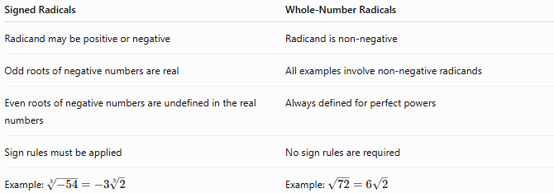
Signed Radicals | Whole-Number Radicals
Radicand may be positive or negative | Radicand is non-negative
Odd roots of negative numbers are real | All examples involve non-negative radicands
Even roots of negative numbers are undefined in the real numbers | Always defined for perfect powers
Sign rules must be applied | No sign rules are required
Example: $\sqrt[3]{-54}=-3\sqrt[3]{2}$ | Example: $\sqrt{72}=6\sqrt{2}$

Conclusion
# Source: AI Source: Provided by: [Data Path: Persons Table -> ID Column: 1, Name_En Column: Motasem Essam] -> From: [ChatGPT] on [7/11/2026]
Simplifying Radicals with Signed Numbers extends the simplification of radicals to expressions involving positive and negative numbers. The sign of the radicand determines whether the radical has a real value: odd-index radicals preserve the sign, while even-index radicals of negative numbers are undefined in the real number system. By combining sign rules with prime factorization and radical properties, signed radicals can be simplified into their simplest equivalent forms for use throughout mathematics, science, and engineering.

Comparison
# Source: AI Source: Provided by: [Data Path: Persons Table -> ID Column: 1, Name_En Column: Motasem Essam] -> From: [ChatGPT] on [7/11/2026]
Comparison of Signed Numbers is the process of determining the relationship between two signed numbers (positive numbers, negative numbers, or zero) based on their numerical values. It identifies whether one signed number is greater than, less than, or equal to another.
Comparison of signed numbers extends whole number comparison by considering the sign of each number and their positions on the number line.

Definition
# Source: AI Source: Provided by: [Data Path: Persons Table -> ID Column: 1, Name_En Column: Motasem Essam] -> From: [ChatGPT] on [7/11/2026]
Signed Number Comparison is the process of comparing two or more signed numbers using comparison symbols.
The possible outcomes are:
- Greater than
- Less than
- Equal to
- Greater than or equal to
- Less than or equal to

Comparison Symbols
# Source: AI Source: Provided by: [Data Path: Persons Table -> ID Column: 1, Name_En Column: Motasem Essam] -> From: [ChatGPT] on [7/11/2026]
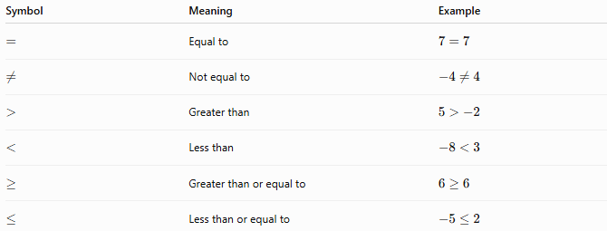
Symbol | Meaning | Example
$$=$$ | Equal to | $$7=7$$
$$≠$$ | Not equal to | $$-4≠4$$
$$>$$ | Greater than | $$5>-2$$
$$<$$ | Less than | $$-8<3$$
$$≥$$ | Greater than or equal to | $$6≥6$$
$$≤$$ | Less than or equal to | $$-5≤2$$

Rules for Comparing Signed Numbers

1. Positive Numbers Are Greater Than Negative Numbers
# Source: AI Source: Provided by: [Data Path: Persons Table -> ID Column: 1, Name_En Column: Motasem Essam] -> From: [ChatGPT] on [7/11/2026]
Every positive number is greater than every negative number.
Examples
$$8>-3 \\ 1>-100$$

2. Zero Is Greater Than Any Negative Number and Less Than Any Positive Number
# Source: AI Source: Provided by: [Data Path: Persons Table -> ID Column: 1, Name_En Column: Motasem Essam] -> From: [ChatGPT] on [7/11/2026]
Examples
$$0>-7 \\ 0<5 \\ 0=0$$

3. Compare Positive Numbers as Whole Numbers
# Source: AI Source: Provided by: [Data Path: Persons Table -> ID Column: 1, Name_En Column: Motasem Essam] -> From: [ChatGPT] on [7/11/2026]
If both numbers are positive, compare them using the usual whole number comparison rules.
Examples
$$15>9 \\ 42<105$$

4. Compare Negative Numbers Using Their Absolute Values
# Source: AI Source: Provided by: [Data Path: Persons Table -> ID Column: 1, Name_En Column: Motasem Essam] -> From: [ChatGPT] on [7/11/2026]
If both numbers are negative:
- The number with the smaller absolute value is greater.
- The number with the larger absolute value is less.
Examples
$$-3>-8$$
because
$$∣-3∣=3<8=∣-8∣.$$

$$-25<-9$$
because
$$25>9.$$

5. Equal Signed Numbers
# Source: AI Source: Provided by: [Data Path: Persons Table -> ID Column: 1, Name_En Column: Motasem Essam] -> From: [ChatGPT] on [7/11/2026]
Two signed numbers are equal only if they have the same sign and the same magnitude.
Examples
$$-12=-12 \\ 9=9$$

6. Use the Number Line
# Source: AI Source: Provided by: [Data Path: Persons Table -> ID Column: 1, Name_En Column: Motasem Essam] -> From: [ChatGPT] on [7/11/2026]
On a number line:
- Numbers to the right are greater.
- Numbers to the left are smaller.
Example
$$-4<-1<0<3<8$$

7. Compare Multiple Signed Numbers
# Source: AI Source: Provided by: [Data Path: Persons Table -> ID Column: 1, Name_En Column: Motasem Essam] -> From: [ChatGPT] on [7/11/2026]
Arrange signed numbers in ascending or descending order using the comparison rules.
Ascending Order
$$-9<-4<0<5<12$$
Descending Order
$$12>5>0>-4>-9$$

Examples
# Source: AI Source: Provided by: [Data Path: Persons Table -> ID Column: 1, Name_En Column: Motasem Essam] -> From: [ChatGPT] on [7/11/2026]
Example 1
Compare
$$7$$
and
$$-2.$$
Since every positive number is greater than every negative number,
$$7>-2.$$

Example 2
Compare
$$-6$$
and
$$-10.$$
Since
$$∣-6∣<∣-10∣, \\ -6>-10.$$

Example 3
Compare
$$0$$
and
$$-15. \\ 0>-15.$$

Example 4
Compare
$$18$$
and
$$25. \\ 18<25.$$

Example 5
Arrange in ascending order:
$$4, -8, 0, 12, -3$$
Answer:
$$-8<-3<0<4<12.$$

Example 6
Arrange in descending order:
$$-12, 6, 0, -2, 15$$
Answer:
$$15>6>0>-2>-12.$$

Applications
# Source: AI Source: Provided by: [Data Path: Persons Table -> ID Column: 1, Name_En Column: Motasem Essam] -> From: [ChatGPT] on [7/11/2026]
Comparison of signed numbers is used in:
- Arithmetic
- Algebra
- Number Lines
- Coordinate Geometry
- Physics
- Finance
- Computer Science
- Data Analysis
- Engineering
- Statistics

Properties
# Source: AI Source: Provided by: [Data Path: Persons Table -> ID Column: 1, Name_En Column: Motasem Essam] -> From: [ChatGPT] on [7/11/2026]
- Every pair of signed numbers can be compared.
- Exactly one of the following is always true:
  - $a<b$
  - $a=b$
  - $a>b$
- Positive numbers are always greater than negative numbers.
- Zero separates positive and negative numbers.
- Among negative numbers, the number closer to zero is greater.

Real-Life Applications
# Source: AI Source: Provided by: [Data Path: Persons Table -> ID Column: 1, Name_En Column: Motasem Essam] -> From: [ChatGPT] on [7/11/2026]
Comparison of signed numbers is used in:
- Comparing temperatures above and below zero
- Measuring elevations above and below sea level
- Tracking financial profits and losses
- Monitoring bank account balances
- Recording gains and losses in stock markets
- Scientific measurements
- Computer programming
- Weather forecasting
- Sports score differences
- Data sorting

Real-Life Examples
# Source: AI Source: Provided by: [Data Path: Persons Table -> ID Column: 1, Name_En Column: Motasem Essam] -> From: [ChatGPT] on [7/11/2026]
1. Temperature
A temperature of
$$-2^{∘}\text{C}$$
is colder than
$$5^{∘}\text{C}.$$
Therefore,
$$-2<5.$$

2. Banking
A balance of
$$\$200$$
is greater than an overdraft of
$$-\$50.$$

3. Elevation
An elevation of
$$150\text{ m}$$
is higher than
$$-20\text{ m}$$
(relative to sea level).

4. Programming
Sorting algorithms compare signed integers when ordering data.

5. Finance
A profit of
$$\$500$$
is greater than a loss of
$$-\$300.$$

6. Weather
A temperature of
$$-{10}^{∘}\text{C}$$
is lower than
$$-4^{∘}\text{C}.$$

Common Mistakes
# Source: AI Source: Provided by: [Data Path: Persons Table -> ID Column: 1, Name_En Column: Motasem Essam] -> From: [ChatGPT] on [7/11/2026]
- Assuming a negative number with a larger absolute value is greater.
- Forgetting that every positive number is greater than every negative number.
- Confusing absolute value with the actual value.
- Ignoring the position of numbers on the number line.
- Misreading the comparison symbols < and >.

Key Points
# Source: AI Source: Provided by: [Data Path: Persons Table -> ID Column: 1, Name_En Column: Motasem Essam] -> From: [ChatGPT] on [7/11/2026]
- Positive numbers are always greater than negative numbers.
- Zero is greater than every negative number and less than every positive number.
- Compare positive numbers as usual.
- For negative numbers, the number with the smaller absolute value is greater.
- Numbers farther to the right on the number line are greater.
- Comparison is the foundation for ordering signed numbers.

Signed Number Comparison vs. Whole Number Comparison
# Source: AI Source: Provided by: [Data Path: Persons Table -> ID Column: 1, Name_En Column: Motasem Essam] -> From: [ChatGPT] on [7/11/2026]
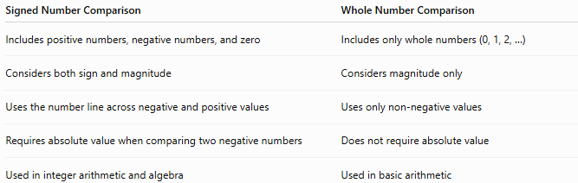
Signed Number Comparison | Whole Number Comparison
Includes positive numbers, negative numbers, and zero | Includes only whole numbers (0, 1, 2, …)
Considers both sign and magnitude | Considers magnitude only
Uses the number line across negative and positive values | Uses only non-negative values
Requires absolute value when comparing two negative numbers | Does not require absolute value
Used in integer arithmetic and algebra | Used in basic arithmetic

Conclusion
# Source: AI Source: Provided by: [Data Path: Persons Table -> ID Column: 1, Name_En Column: Motasem Essam] -> From: [ChatGPT] on [7/11/2026]
Comparison of Signed Numbers is the process of determining whether one signed number is greater than, less than, or equal to another. The comparison is based on the sign of each number, their magnitudes, and their positions on the number line. Positive numbers are always greater than negative numbers, zero separates positive and negative values, and among negative numbers, the number closer to zero is greater. This concept is fundamental to arithmetic, algebra, inequalities, and many real-world applications involving temperatures, finances, elevations, and computing.

Ordering
# Source: AI Source: Provided by: [Data Path: Persons Table -> ID Column: 1, Name_En Column: Motasem Essam] -> From: [ChatGPT] on [7/11/2026]
Ordering Signed Numbers is the process of arranging two or more signed numbers (positive numbers, negative numbers, and zero) according to their numerical values, either from smallest to largest (ascending order) or from largest to smallest (descending order).
Ordering signed numbers is based on comparison of signed numbers and the number line, where numbers farther to the right are greater and numbers farther to the left are smaller.

Definition
# Source: AI Source: Provided by: [Data Path: Persons Table -> ID Column: 1, Name_En Column: Motasem Essam] -> From: [ChatGPT] on [7/11/2026]
Ordering Signed Numbers is the process of arranging signed numbers according to their values.
The two common types of ordering are:
- Ascending Order (smallest to largest)
- Descending Order (largest to smallest)

Types of Ordering

1. Ascending Order
# Source: AI Source: Provided by: [Data Path: Persons Table -> ID Column: 1, Name_En Column: Motasem Essam] -> From: [ChatGPT] on [7/11/2026]
Numbers are arranged from the smallest value to the largest value.
Example
Arrange
$$4, -7, 0, 12, -2$$
in ascending order.
$$-7<-2<0<4<12$$

2. Descending Order
# Source: AI Source: Provided by: [Data Path: Persons Table -> ID Column: 1, Name_En Column: Motasem Essam] -> From: [ChatGPT] on [7/11/2026]
Numbers are arranged from the largest value to the smallest value.
Example
Arrange
$$4, -7, 0, 12, -2$$
in descending order.
$$12>4>0>-2>-7$$

Rules for Ordering Signed Numbers

1. Negative Numbers Come Before Zero and Positive Numbers in Ascending Order
# Source: AI Source: Provided by: [Data Path: Persons Table -> ID Column: 1, Name_En Column: Motasem Essam] -> From: [ChatGPT] on [7/11/2026]
Every negative number is less than zero, and zero is less than every positive number.
Example
Arrange
$$-5, 0, 8, -2, 3$$
Ascending:
$$-5<-2<0<3<8$$

2. Positive Numbers Are Ordered Like Whole Numbers
# Source: AI Source: Provided by: [Data Path: Persons Table -> ID Column: 1, Name_En Column: Motasem Essam] -> From: [ChatGPT] on [7/11/2026]
When ordering positive numbers, use the usual whole number comparison rules.
Example
Arrange
$$15, 4, 29, 8$$
Ascending:
$$4<8<15<29$$

3. Order Negative Numbers by Their Absolute Values
# Source: AI Source: Provided by: [Data Path: Persons Table -> ID Column: 1, Name_En Column: Motasem Essam] -> From: [ChatGPT] on [7/11/2026]
Among negative numbers:
- The number with the larger absolute value is smaller.
- The number with the smaller absolute value is greater.
Example
Arrange
$$-3, -8, -1, -5$$
Ascending:
$$-8<-5<-3<-1$$

4. Zero Separates Negative and Positive Numbers
# Source: AI Source: Provided by: [Data Path: Persons Table -> ID Column: 1, Name_En Column: Motasem Essam] -> From: [ChatGPT] on [7/11/2026]
Zero is greater than every negative number and less than every positive number.
Example
Arrange
$$5, 0, -7, 2, -1$$
Ascending:
$$-7<-1<0<2<5$$

5. Reverse the Ascending Order to Obtain Descending Order
# Source: AI Source: Provided by: [Data Path: Persons Table -> ID Column: 1, Name_En Column: Motasem Essam] -> From: [ChatGPT] on [7/11/2026]
Descending order is simply the reverse of ascending order.
Example
Ascending:
$$-9<-2<0<6<14$$
Descending:
$$14>6>0>-2>-9$$

6. Equal Numbers Remain Together
# Source: AI Source: Provided by: [Data Path: Persons Table -> ID Column: 1, Name_En Column: Motasem Essam] -> From: [ChatGPT] on [7/11/2026]
Equal signed numbers occupy the same relative position in the ordered list.
Example
Arrange
$$-4, 7, -4, 0, 7$$
Ascending:
$$-4=-4<0<7=7$$

7. Use the Number Line
# Source: AI Source: Provided by: [Data Path: Persons Table -> ID Column: 1, Name_En Column: Motasem Essam] -> From: [ChatGPT] on [7/11/2026]
Numbers farther to the left on the number line are smaller.
Numbers farther to the right are greater.
Example
Arrange
$$3, -6, 1, -2, 0$$
Ascending:
$$-6<-2<0<1<3$$

Examples
# Source: AI Source: Provided by: [Data Path: Persons Table -> ID Column: 1, Name_En Column: Motasem Essam] -> From: [ChatGPT] on [7/11/2026]
Example 1
Arrange in ascending order:
$$4, -8, 0, 12, -3$$
Answer:
$$-8<-3<0<4<12$$

Example 2
Arrange in descending order:
$$-12, 6, 0, -2, 15$$
Answer:
$$15>6>0>-2>-12$$

Example 3
Arrange in ascending order:
$$9, -1, -15, 7, 0$$
Answer:
$$-15<-1<0<7<9$$

Example 4
Arrange in descending order:
$$-5, -11, 4, 18, 2$$
Answer:
$$18>4>2>-5>-11$$

Example 5
Arrange in ascending order:
$$-25, -7, -18, -2$$
Answer:
$$-25<-18<-7<-2$$

Example 6
Arrange in descending order:
$$0, -100, 25, -4, 8$$
Answer:
$$25>8>0>-4>-100$$

Applications
# Source: AI Source: Provided by: [Data Path: Persons Table -> ID Column: 1, Name_En Column: Motasem Essam] -> From: [ChatGPT] on [7/11/2026]
Ordering signed numbers is used in:
- Arithmetic
- Algebra
- Coordinate Geometry
- Number Lines
- Physics
- Finance
- Computer Science
- Statistics
- Data Analysis
- Engineering

Properties
# Source: AI Source: Provided by: [Data Path: Persons Table -> ID Column: 1, Name_En Column: Motasem Essam] -> From: [ChatGPT] on [7/11/2026]
- Every collection of signed numbers has a unique ascending order.
- Every collection of signed numbers has a unique descending order.
- Negative numbers always come before zero in ascending order.
- Positive numbers always come after zero in ascending order.
- Ordering is based on comparison and the number line.
- Equal numbers remain together in the ordered sequence.

Real-Life Applications
# Source: AI Source: Provided by: [Data Path: Persons Table -> ID Column: 1, Name_En Column: Motasem Essam] -> From: [ChatGPT] on [7/11/2026]
Ordering signed numbers is used in:
- Ranking temperatures above and below zero
- Ordering elevations relative to sea level
- Sorting financial gains and losses
- Bank account balances
- Scientific measurements
- Programming and sorting algorithms
- Weather forecasting
- Data analysis
- Engineering measurements
- Geographic elevations

Real-Life Examples
# Source: AI Source: Provided by: [Data Path: Persons Table -> ID Column: 1, Name_En Column: Motasem Essam] -> From: [ChatGPT] on [7/11/2026]
1. Temperature
Arrange the temperatures
$$-8^{∘}\text{C}, 3^{∘}\text{C}, 0^{∘}\text{C}, -2^{∘}\text{C}$$
from coldest to warmest:
$$-8<-2<0<3$$

2. Banking
Arrange account balances
$$-\$120, \$450, \$0, -\$30$$
Ascending:
$$-120<-30<0<450$$

3. Elevation
Arrange elevations
$$-50\text{ m}, 120\text{ m}, 0\text{ m}, -10\text{ m}$$
Ascending:
$$-50<-10<0<120$$

4. Programming
Sorting algorithms arrange signed integers according to their values.

5. Weather
Arrange daily temperatures from lowest to highest.

6. Stock Market
Arrange daily profits and losses from the largest loss to the largest profit.

Common Mistakes
# Source: AI Source: Provided by: [Data Path: Persons Table -> ID Column: 1, Name_En Column: Motasem Essam] -> From: [ChatGPT] on [7/11/2026]
- Forgetting that all negative numbers are less than zero.
- Assuming that a negative number with a larger absolute value is greater.
- Confusing ascending and descending order.
- Ignoring the position of zero.
- Misreading comparison symbols.
- Comparing only absolute values instead of the actual signed values.

Key Points
# Source: AI Source: Provided by: [Data Path: Persons Table -> ID Column: 1, Name_En Column: Motasem Essam] -> From: [ChatGPT] on [7/11/2026]
- Ordering signed numbers means arranging them by their numerical values.
- Ascending order goes from the smallest value to the largest.
- Descending order goes from the largest value to the smallest.
- Negative numbers come before zero, and zero comes before positive numbers in ascending order.
- Among negative numbers, the number with the greater absolute value is smaller.
- The number line provides a visual method for ordering signed numbers.

Signed Number Ordering vs. Signed Number Comparison
# Source: AI Source: Provided by: [Data Path: Persons Table -> ID Column: 1, Name_En Column: Motasem Essam] -> From: [ChatGPT] on [7/11/2026]
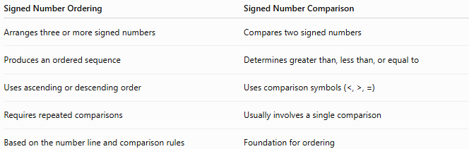
Signed Number Ordering | Signed Number Comparison
Arranges three or more signed numbers | Compares two signed numbers
Produces an ordered sequence | Determines greater than, less than, or equal to
Uses ascending or descending order | Uses comparison symbols (<, >, =)
Requires repeated comparisons | Usually involves a single comparison
Based on the number line and comparison rules | Foundation for ordering

Conclusion
# Source: AI Source: Provided by: [Data Path: Persons Table -> ID Column: 1, Name_En Column: Motasem Essam] -> From: [ChatGPT] on [7/11/2026]
Ordering Signed Numbers is the process of arranging signed numbers from smallest to largest (ascending order) or from largest to smallest (descending order). It relies on comparing the signs and magnitudes of the numbers and interpreting their positions on the number line. Negative numbers come before zero, zero comes before positive numbers, and among negative numbers, the value closer to zero is greater. Ordering signed numbers is an essential skill in arithmetic, algebra, science, finance, computing, and many real-world applications.

Find Numbers

One number between two numbers

Definition
# Source: AI Source: Provided by: [Data Path: Persons Table -> ID Column: 1, Name_En Column: Motasem Essam] -> From: [ChatGPT] on [7/11/2026]
Finding a number between two signed numbers means identifying a signed number whose value is greater than the smaller signed number and less than the larger signed number.
Signed numbers include:
- Negative numbers
- Zero
- Positive numbers

Rule
# Source: AI Source: Provided by: [Data Path: Persons Table -> ID Column: 1, Name_En Column: Motasem Essam] -> From: [ChatGPT] on [7/11/2026]
If two signed numbers satisfy:
$$a<b$$
then any signed number $x$is between them if:
$$a<x<b$$

Method — Find the Middle Number
# Source: AI Source: Provided by: [Data Path: Persons Table -> ID Column: 1, Name_En Column: Motasem Essam] -> From: [ChatGPT] on [7/11/2026]
When the sum of the two signed numbers is even, the midpoint is a signed integer.
The midpoint is:
$$\frac{a+b}{2}$$
Example 1
Find a number between:
$$-6 \text{and} 2 \\ \frac{-6+2}{2}=\frac{-4}{2}=-2$$
So:
$$-2$$
is exactly between them.

Example 2
Find a number between:
$$4 \text{and} 10 \\ \frac{4+10}{2}=7$$
Therefore:
$$7$$
lies exactly between them.

Number Line Illustration
# Source: AI Source: Provided by: [Data Path: Persons Table -> ID Column: 1, Name_En Column: Motasem Essam] -> From: [ChatGPT] on [7/11/2026]
Example
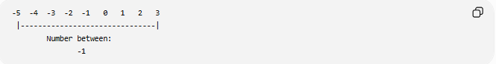
-5 -4 -3 -2 -1 0 1 2 3
|-------------------------------|
Number between:
-1

Applications
# Source: AI Source: Provided by: [Data Path: Persons Table -> ID Column: 1, Name_En Column: Motasem Essam] -> From: [ChatGPT] on [7/11/2026]
Finding numbers between signed numbers is used in:
- Arithmetic
- Number Lines
- Integer Ordering
- Coordinate Geometry
- Estimation
- Computer Science
- Data Analysis

Key Points
# Source: AI Source: Provided by: [Data Path: Persons Table -> ID Column: 1, Name_En Column: Motasem Essam] -> From: [ChatGPT] on [7/11/2026]
- A number between two signed numbers must satisfy:
$$a<x<b$$
- The midpoint is:
$$\frac{a+b}{2}$$
when it is an integer.
- A number between two signed numbers may be:
  - Negative
  - Zero
  - Positive
depending on the interval.

Conclusion
# Source: AI Source: Provided by: [Data Path: Persons Table -> ID Column: 1, Name_En Column: Motasem Essam] -> From: [ChatGPT] on [7/11/2026]
Finding a number between two signed numbers involves identifying any signed number whose value lies strictly between the given numbers. This can be done by selecting any valid integer in the interval or, when possible, by calculating the midpoint. The concept is fundamental in arithmetic, integer ordering, number lines, coordinate geometry, estimation, computer science, and mathematical reasoning.

More Than One Number Between two Numbers

Definition
# Source: AI Source: Provided by: [Data Path: Persons Table -> ID Column: 1, Name_En Column: Motasem Essam] -> From: [ChatGPT] on [7/11/2026]
Finding more than one number between two signed numbers means identifying all signed integers (or several signed integers) whose values are greater than the smaller signed number and less than the larger signed number.
Signed numbers include:
- Negative integers
- Zero
- Positive integers

Rule
# Source: AI Source: Provided by: [Data Path: Persons Table -> ID Column: 1, Name_En Column: Motasem Essam] -> From: [ChatGPT] on [7/11/2026]
Let:
$$a<b$$
Any signed integer $x$is between them if:
$$a<x<b$$
If the difference between the two signed numbers is greater than 2, then more than one signed integer exists between them.

Method
# Source: AI Source: Provided by: [Data Path: Persons Table -> ID Column: 1, Name_En Column: Motasem Essam] -> From: [ChatGPT] on [7/11/2026]
- Identify the smaller and larger signed numbers.
- Count upward by 1 from the smaller number.
- Stop before reaching the larger number.

Examples
# Source: AI Source: Provided by: [Data Path: Persons Table -> ID Column: 1, Name_En Column: Motasem Essam] -> From: [ChatGPT] on [7/11/2026]
Example 1
Find the signed numbers between:
$$-8 \text{and} -2$$
The signed numbers are:
$$-7, -6, -5, -4, -3$$

Example 2
Find the signed numbers between:
$$-5 \text{and} 4$$
The signed numbers are:
$$-4, -3, -2, -1, 0, 1, 2, 3$$

Example 3
Find the signed numbers between:
$$3 \text{and} 9$$
The signed numbers are:
$$4, 5, 6, 7, 8$$

Example 4
Find the signed numbers between:
$$-12 \text{and} -6$$
The signed numbers are:
$$-11, -10, -9, -8, -7$$

Number of Signed Integers Between Two Signed Numbers
# Source: AI Source: Provided by: [Data Path: Persons Table -> ID Column: 1, Name_En Column: Motasem Essam] -> From: [ChatGPT] on [7/11/2026]
If:
$$a<b$$
then the number of signed integers between them is:
$$\left(b-a\right)-1$$

Example
Between:
$$-7 \text{and} 5$$
Number of signed integers:
$$\left(5-\left(-7\right)\right)-1=12-1=11$$
They are:
$$-6, -5, -4, -3, -2, -1, 0, 1, 2, 3, 4$$

Special Cases

Consecutive Signed Numbers
# Source: AI Source: Provided by: [Data Path: Persons Table -> ID Column: 1, Name_En Column: Motasem Essam] -> From: [ChatGPT] on [7/11/2026]
Between:
$$-3 \text{and} -2$$
there are no signed integers.

Exactly One Signed Integer
# Source: AI Source: Provided by: [Data Path: Persons Table -> ID Column: 1, Name_En Column: Motasem Essam] -> From: [ChatGPT] on [7/11/2026]
Between:
$$5 \text{and} 7$$
there is only:
$$6$$

Number Line Illustration
# Source: AI Source: Provided by: [Data Path: Persons Table -> ID Column: 1, Name_En Column: Motasem Essam] -> From: [ChatGPT] on [7/11/2026]
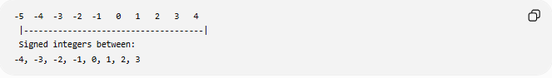
-5 -4 -3 -2 -1 0 1 2 3 4
|-------------------------------------|
Signed integers between:
-4, -3, -2, -1, 0, 1, 2, 3

Applications
# Source: AI Source: Provided by: [Data Path: Persons Table -> ID Column: 1, Name_En Column: Motasem Essam] -> From: [ChatGPT] on [7/11/2026]
Finding multiple signed numbers between two signed numbers is used in:
- Arithmetic
- Integer Ordering
- Number Lines
- Coordinate Geometry
- Computer Programming
- Data Analysis
- Mathematical Modeling

Key Points
# Source: AI Source: Provided by: [Data Path: Persons Table -> ID Column: 1, Name_En Column: Motasem Essam] -> From: [ChatGPT] on [7/11/2026]
- A signed integer between two signed numbers satisfies:
$$a<x<b$$
- All intermediate signed integers can be found by counting upward from the smaller number.
- The number of signed integers between two signed numbers is:
$$\left(b-a\right)-1$$
- The list of numbers may include:
  - Negative integers
  - Zero
  - Positive integers
depending on the interval.

Conclusion
# Source: AI Source: Provided by: [Data Path: Persons Table -> ID Column: 1, Name_En Column: Motasem Essam] -> From: [ChatGPT] on [7/11/2026]
Finding more than one signed number between two signed numbers involves listing every signed integer whose value lies strictly between the given numbers. This process applies equally to intervals containing only negative numbers, only positive numbers, or a mix of both, including zero. It is a fundamental concept in arithmetic, integer ordering, number lines, coordinate geometry, programming, data analysis, and mathematical reasoning.

Finding Two Consecutive Numbers That a Number Lies Between

Definition
# Source: AI Source: Provided by: [Data Path: Persons Table -> ID Column: 1, Name_En Column: Motasem Essam] -> From: [ChatGPT] on [7/11/2026]
Finding the two consecutive whole numbers that a signed number lies between means identifying the two neighboring whole numbers such that the given signed number is greater than or equal to the smaller whole number and less than the larger whole number.
These two whole numbers always differ by exactly 1.
This concept applies to:
- Negative signed numbers
- Zero
- Positive signed numbers

Rule
# Source: AI Source: Provided by: [Data Path: Persons Table -> ID Column: 1, Name_En Column: Motasem Essam] -> From: [ChatGPT] on [7/11/2026]
Let the signed number be:
$$x$$
The two consecutive whole numbers are:
- The greatest whole number less than or equal to $x$.
- The next whole number immediately after it.
If the smaller whole number is $n$, then:
$$n≤x<n+1$$
Therefore, the required consecutive whole numbers are:
$$n \text{and} n+1$$

Examples
# Source: AI Source: Provided by: [Data Path: Persons Table -> ID Column: 1, Name_En Column: Motasem Essam] -> From: [ChatGPT] on [7/11/2026]
Example 1
Find the two consecutive whole numbers that:
$$-3$$
lies between.
Since:
$$-4<-3<-2$$
The two consecutive whole numbers are:
$$-4\text{ and }-2$$

Example 2
Find the two consecutive whole numbers that:
$$5$$
lies between.
Since:
$$4<5<6$$
The answer is:
$$4\text{ and }6$$

Example 3
Find the two consecutive whole numbers that:
$$12$$
lies between.
Since:
$$11<12<13$$
The answer is:
$$11\text{ and }13$$

Example 4
Find the two consecutive whole numbers that:
$$0$$
lies between.
Since:
$$-1<0<1$$
The answer is:
$$-1\text{ and }1$$

Number Line Illustration
# Source: AI Source: Provided by: [Data Path: Persons Table -> ID Column: 1, Name_En Column: Motasem Essam] -> From: [ChatGPT] on [7/11/2026]
Example
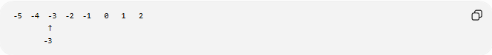
-5 -4 -3 -2 -1 0 1 2
↑
-3
The signed number −3 lies between the consecutive whole numbers:
$$-4\text{ and }-2$$

Applications
# Source: AI Source: Provided by: [Data Path: Persons Table -> ID Column: 1, Name_En Column: Motasem Essam] -> From: [ChatGPT] on [7/11/2026]
This concept is used in:
- Arithmetic
- Number Lines
- Integer Ordering
- Estimation
- Coordinate Geometry
- Computer Science
- Data Analysis

Key Points
# Source: AI Source: Provided by: [Data Path: Persons Table -> ID Column: 1, Name_En Column: Motasem Essam] -> From: [ChatGPT] on [7/11/2026]
- Every signed number has one neighboring whole number before it and one after it.
- If the signed number is a whole number $n$, it lies between:
$$n-1 \text{and} n+1$$
Examples:
- $-3$lies between −4 and −2.
- $0$lies between −1 and 1.
- $5$lies between 4 and 6.

Conclusion
# Source: AI Source: Provided by: [Data Path: Persons Table -> ID Column: 1, Name_En Column: Motasem Essam] -> From: [ChatGPT] on [7/11/2026]
Finding the two consecutive whole numbers that a signed number lies between involves identifying the whole number immediately before and immediately after the given signed number. If the signed number is $n$, then it lies between $n-1$and $n+1$, which are consecutive whole numbers. This concept is fundamental in arithmetic, number lines, integer ordering, estimation, coordinate geometry, and mathematical reasoning.

